**RobotLinking**

**THE 37 SENSOR KIT TUTORIAL**

**Preface**

### About RobotLinking

RobotLinking is a technology company focused on 3D Printer, Raspberry Pi and Arduino open source community development. Committed to the promotion of open source culture, we strive to bring the fun of electronics making to people all around the world and enable everyone to be a maker. Our products include learning kits, development boards, robots, sensor modules, development tools and printer machine. In addition to high quality products, RobotLinking also offers video tutorials to help your own project. If you have interest in open source or making something cool, welcome to join us! Visit [www.RobotLinking.com](http://www.sunfounder.com/) for more!

### About 37 Sensor Kit

This 37 Sensor Kit is suitable for RobotLinking Uno, RobotLinking Mega 2560, RobotLinking Duemilanove and RobotLinking Nano. All the code in this user guide is also compatible with these boards.

Our RobotLinking board is fully compatible with Arduino.

This kit walks you through the basics of using the RobotLinking board in a hands-on way. You'll learn through building several creative projects. The kit includes a selection of the most common and useful electronic components. Starting from the basics of electronics, to more complex projects, the kit will help you control the physical world with components.

In this book, we will show you circuits with both realistic illustrations and schematic diagrams. You can go to our official website [www.RobotLinking.com](http://www.sunfounder.com/) to download related code.

If you have any questions, please send an email to [support@RobotLinking.com](mailto:support@sunfounder.com). You can also leave a message and share your projects on our forum.

**Contents**

Lesson 1 DS18B20 DIGITAL TEMPERATURE SENSOR MODULE 11

Lesson 2 VIBRATION SWITCH MODULE 13

Lesson 3 HALL MAGNETIC SENSOR MODULE 15

Lesson 4 SWITCH MODULE 17

Lesson 5 IR send and IR incept 19

Lesson 6 PASSIVE BUZZER MODULE 24

Lesson 7 LASER MODULE 26

Lesson 8 SMD RGB MODULE AND RGB MODULE 28

Lesson 9 TEMP AND HUMIDITY MODULE 31

Lesson 10 LIGHT BLOCKING MODULE 34

Lesson 11 TILT SWITCH MODULE 36

Lesson 12 BALL SWITCH MODULE 38

Lesson 13 REED SWITCH AND MINI REED SWITCH MODULE 40

Lesson 14 TWO-COLOR LED MODULE AND MINI TWO-COLOR LED MODULE 43

Lesson 15 TAP MODULE 46

Lesson 16 DIGITAL TEMPERATURE MODULE 48

Lesson 17 FLAME SENSOR MODULE 50

Lesson 18 MENTAL TOUCH MODULE 52

Lesson 19 ANALOG TEMP MODULE 54

Lesson 20 PHOTORESISTOR MODULE 57

Lesson 21 7 COLOR FLASH LED MODULE 60

Lesson 22 BIG SOUND SENSOR MODULE AND SMALL SOUND SENSOR MODULE 62

Lesson 23 LIGHT CUP MODULE 65

Lesson 24 JOYSTICK MODULE 67

Lesson 25 LINEAR HALL AND ANALOG HALL MODULE 70

Lesson 26 TRACKING MODULE AND AVOIDANCE MODULE 73

Lesson 27 ROTARY ENCODERS MODULE 76

Lesson 28 1 CHANNEL RELAY MODULE 79

Lesson 29 HEARTBEAT MODULE 81

# Components List

|  |  |  |  |
| --- | --- | --- | --- |
| No | Product Name | Quantity | Picture |
| 1 | DS18B20 Module | 1 |  |
| 2 | Vibration Switch Module | 1 |  |
| 3 | Hall Magnetic sensor Module | 1 |  |
| 4 | Switch Module | 1 |  |
| 5 | IR Receiver | 1 |  |
| 6 | IR Emission | 1 |  |
| 7 | Passive buzzer | 1 |  |
| 8 | Laser module | 1 |  |
| 9 | SMD RGB module | 1 |  |
| 10 | RGB LED module | 1 |  |
| 11 | TEMP and humidity module | 1 |  |
| 12 | Light blocking module | 1 |  |
| 13 | TILT switch module | 1 |  |
| 14 | Ball switch module | 1 |  |
| 15 | Reed switch module | 1 |  |
| 16 | Mini reed switch module | 1 |  |
| 17 | Mini two-color module | 1 |  |
| 18 | Two-color module | 1 |  |
| 19 | Tap module | 1 |  |
| 20 | Digital temperature module | 1 |  |
| 21 | Flame module | 1 |  |
| 22 | Touch module | 1 |  |
| 23 | Analog temp module | 1 |  |
| 24 | Photoresistor module | 1 |  |
| 25 | 7 color flash module | 1 |  |
| 26 | Big sound module | 1 |  |
| 27 | Light cup module | 2 |  |
| 28 | Joystick module | 1 |  |
| 29 | Linear hall module | 1 |  |
| 30 | Analog hall module | 1 |  |
| 31 | Avoidance module | 1 |  |
| 32 | Tracking module | 1 |  |
| 33 | Rotary encoders module | 1 |  |
| 34 | Buzzer module | 1 |  |
| 35 | Heartbeat module | 1 |  |
| 36 | Relay module | 1 |  |
| 37 | Small sound module | 1 |  |

### Note:

After unpacking, please check that the number of components is correct and that all components are in good condition.

# Lesson 1 DS18B20 DIGITAL TEMPERATURE SENSOR MODULE

## Introduction

In this experiment, we will learn how to use DS18B20 module test the environmental temperature and make a thermometer.

Since the previous temperature sensor output is analog. So we need to add additional A/D and D/A chip into the line transformation. More -over, the Arduino external port is not rich resources and the utilization rate is not high. These cause a big challenge. So we are create the Ds18b20 module.

The new DS18B20 Temperature Sensor Module is very good solve the problem. It have the characteristic of the economy, unique 1-wire bus and it can fully apply the Arduino platform. Users can easily form a sensor network through using this module.

## Components

* 1 * RobotLinking Uno board
* 1 * USB cable
* 1 * DS18B20 module
* Dupont wires(Female to Male)

## Principle

DS18B20 module is using a single bus. The power supply voltage range of 3.0 V to 5.5 V and no standby power supply. It can Measure temperature range for -55 degree to +125 degree with accuracy of +/-0.5°C.

The programmable DPI of temperature sensor is From 9 to 12. temperature conversion is 12 digits lattice type. maximum is 750 milliseconds. Families can be defined non-volatile temperature alarm Settings.

Each DS18B20 contains a unique serial number so that multiple ds18b20s can exist in a bus. Temperature sensor can detect temperature in numbers of different places at the same time.

. 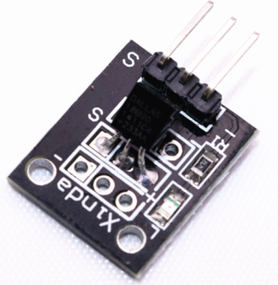

## Experimental Procedures

**Step 1:** Connect circuit as shown in the following photo:

The power cord, ground wire and S port of DS18B20 connected to the Arduino board experiment of +5v, GND and 12 port.

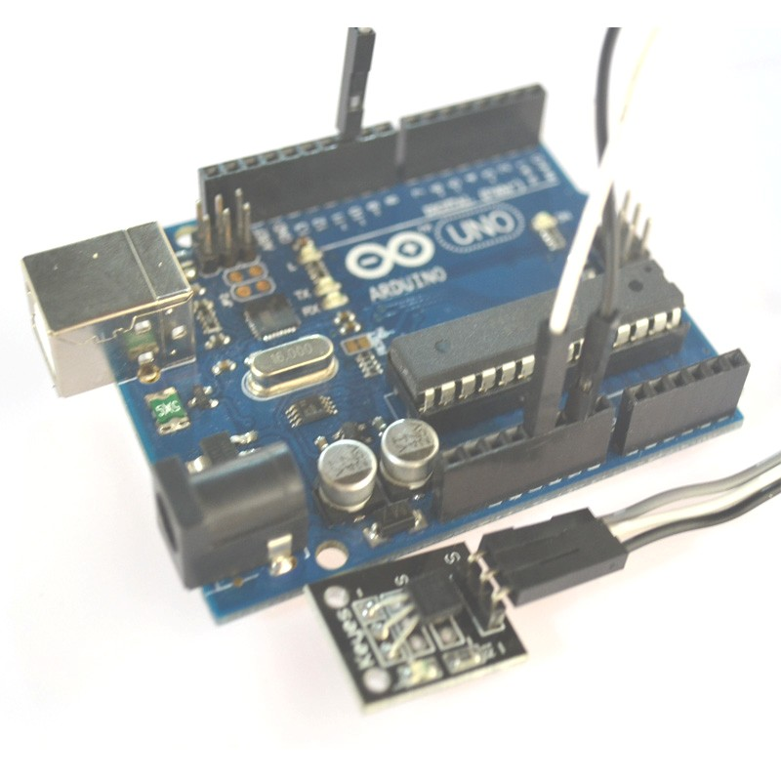

**Step 2:** Open PROJECT → Include Library → Manage Libraries → install the "OneWire" and "DallasTemperature" libraries .

**Step 3:** Program (please refer to the example code on the CD or official website)

**Step 4:** Compile the program

**Step** **5:** Burn the program into RobotLinking Uno board

**Step 6:** Open the TOOL→Serial Monitor, and we can see the temperature. When doing the experiment, the temperature is 27 degrees Celsius. With the hand touch the DS18B20, through the serial port we can be found there is an obvious change in temperature

## Experimental Summary

DS18B20 module are a very simple, very practical technology that is surprisingly easy to master. If you feel as though you're struggling, check out our video tutorials on [www.RobotLinking.com](http://www.sunfounder.com/) or ask us questions on our forum.

# Lesson 2 VIBRATION SWITCH MODULE

## Introduction

In this experiment, we will learn how to use vibration switch module

## Components

* 1 * RobotLinking Uno board
* 1 * USB cable
* 1 * VIBRATION Switch module
* Dupont wires(Female to Male)

## Principle

Vibration module and number 13 port have the built-in LED simple circuit. To produce a vibration flasher, we can use connect the digital port 13 to the built-in LED and connect the vibration S port to number 3 port of RobotLinking Uno board. When the vibration sensor sensing, LED twinkle light to the vibration signal.

. 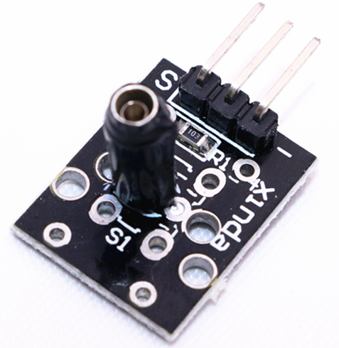

## Experimental Procedures

**Step 1:** Connect circuit as shown in the following photo:

The power cord, ground wire and S port of vibration switch module connected to the Arduino board experiment of +5v, GND and 3 port.



**Step 2:** Program (please refer to the example code on the CD or official website)

**Step 3:** Compile the program

**Step 4:** Burn the program into RobotLinking Uno board

## Experimental Summary

Vibration module are a very simple, very practical technology that is surprisingly easy to master. If you feel as though you're struggling, check out our video tutorials on [www.RobotLinking.com](http://www.sunfounder.com/) or ask us questions on our forum.

# Lesson 3 HALL MAGNETIC SENSOR MODULE

## Introduction

In this experiment, we will learn how to use hall magnetic sensor module.

## Components

* 1 * RobotLinking Uno board
* 1 * USB cable
* 1 * hall magnetic sensor module
* Dupont wires(Female to Male)

## Principle

Hall magnetic module and number 13 port have the built-in LED simple circuit. To produce a magnetic flasher, we can use connect the digital port 13 to the built-in LED and connect the magnetic sensor S port to number 3 port of RobotLinking Uno board. When the hall magnetic sensor sensing, LED twinkle light to the hall magnetic sensor signal.

. 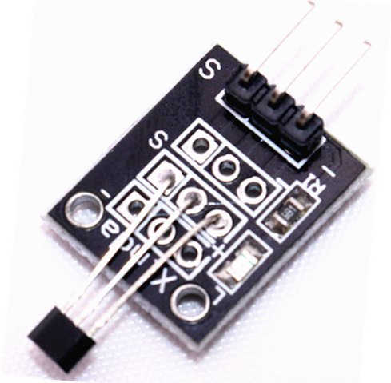

## Experimental Procedures

**Step 1:** Connect circuit as shown in the following photo:

The power cord, ground wire and S port of hall magnetic sensor module connected to the Arduino board experiment of +5v, GND and 3 port.

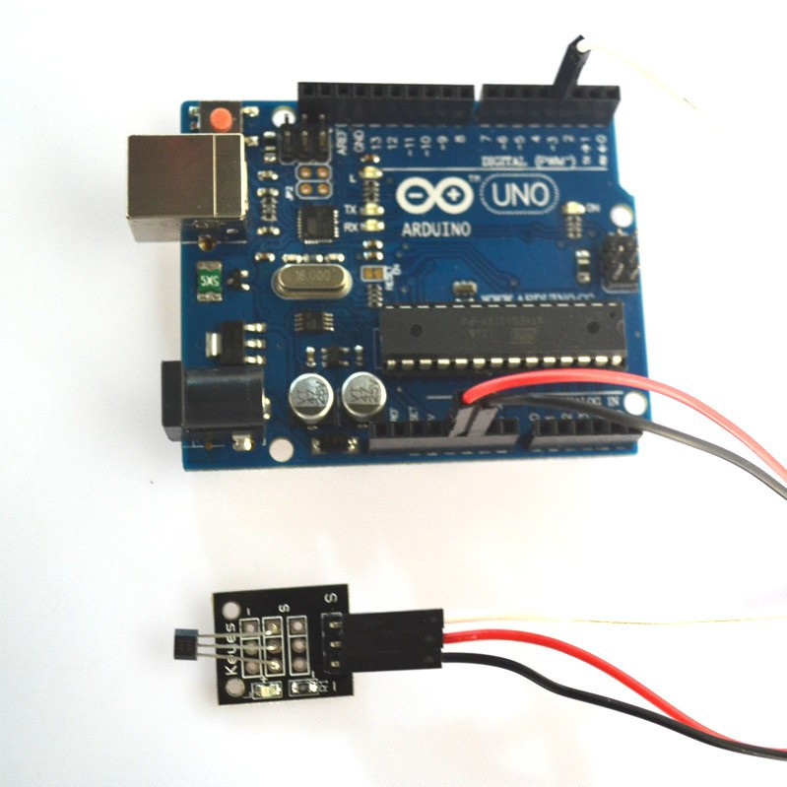

**Step 2:** Program (please refer to the example code on the CD or official website)

**Step 3:** Compile the program

**Step 4:** Burn the program into RobotLinking Uno board

## Experimental Summary

Hall magnetic sensor module are a very simple, very practical technology that is surprisingly easy to master. If you feel as though you're struggling, check out our video tutorials on [www.RobotLinking.com](http://www.sunfounder.com/) or ask us questions on our forum.

# Lesson 4 SWITCH MODULE

## Introduction

In this experiment, we will learn how to use switch module.

## Components

* 1 * RobotLinking Uno board
* 1 * USB cable
* 1 * switch module
* Dupont wires(Female to Male)

## Principle

Switch module and number 13 port have the built-in LED simple circuit. To produce a switch flasher, we can use connect the digital port 13 to the built-in LED and connect the switch module S port to number 3 port of RobotLinking Uno board. When the switch sensing, LED twinkle light to the switch signal.

. 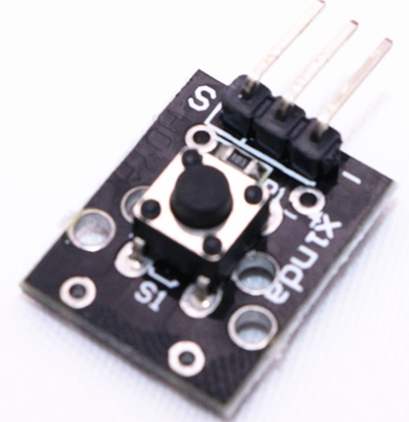

## Experimental Procedures

**Step 1:** Connect circuit as shown in the following photo:

The power cord, ground wire and S port of switch module connected to the Arduino board experiment of +5v, GND and 3 port.

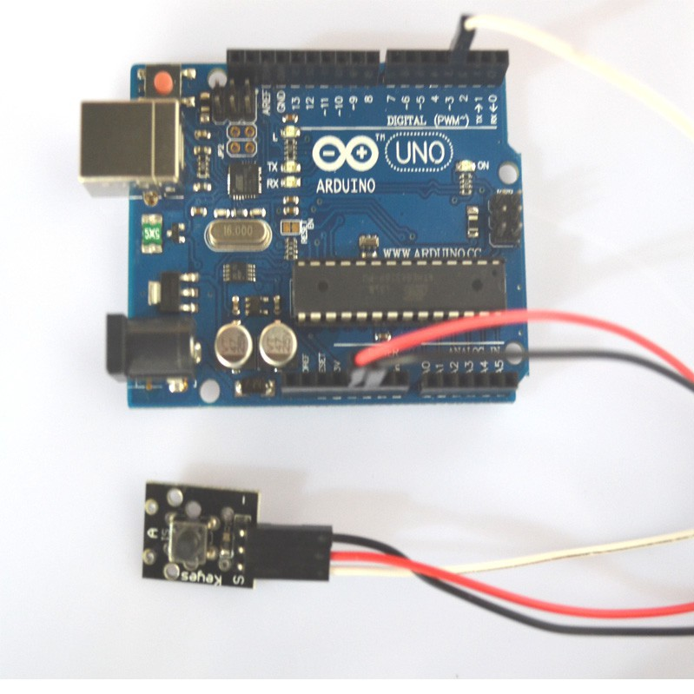

**Step 2:** Program (please refer to the example code on the CD or official website)

**Step 3:** Compile the program

**Step 4:** Burn the program into RobotLinking Uno board

## Experimental Summary

switch module are a very simple, very practical technology that is surprisingly easy to master. If you feel as though you're struggling, check out our video tutorials on [www.RobotLinking.com](http://www.sunfounder.com/) or ask us questions on our forum.

# Lesson 5 IR send and IR incept

## Introduction

In this experiment, we will learn how to use IR send module and IR incept module.

In fact now in our daily life they play an important role, a lot of household electrical appliances are used to this kind of device, such as air conditioning, TV, DVD, etc. Actually it is based on its wireless remote sensing and it is very convenient by using them.

## Components

* 2 * RobotLinking Uno board
* 2 * USB cable
* 1 * IR send module
* 1 * IR incept module
* Dupont wires(Female to Male)

## Principle

Firstly, let's know the structure of the infrared receiving head: there are two important elements inside the infrared receiving head, IC and PD. IC is receiving head processing components, mainly composed of silicon and circuit. It is a highly integrated device. The main function is filter, plastic, decoding, amplification, etc. PD is a photosensitive diode. The main function is to receive the light signal.

. 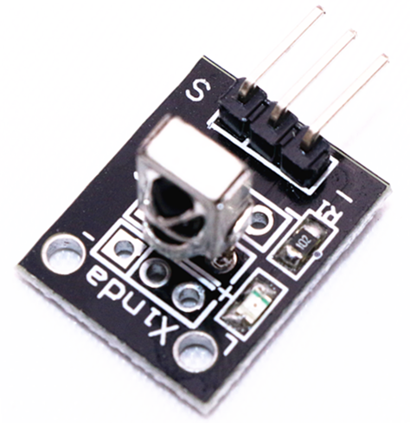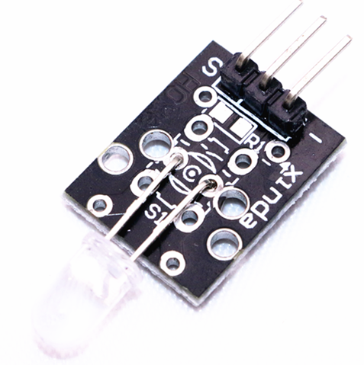

Below is a brief working principle diagram:

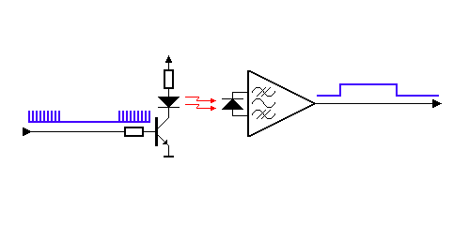

Infrared emitting diode launch out the modulation signal and infrared receiver head will receive, decode, filter and so on to regain the signal .

Infrared emitting diode: keep clean and in good condition. All the parameters in the process of working shall not exceed the limit value (positive To the current 30~60mA, positive pulse current 0.3~1A, reverse voltage 5V, dissipation power 90mW, working temperature range -25~+80℃, and storage temperature range between 40~100℃, the welding temperature 260 ℃) infrared tube with a closed head should be matching use, otherwise it will influence the sensitivity.

## Experimental Procedures

**Step 1:** We first look at diagram, understand the infrared emission and receiving module specific connection with Arduino:

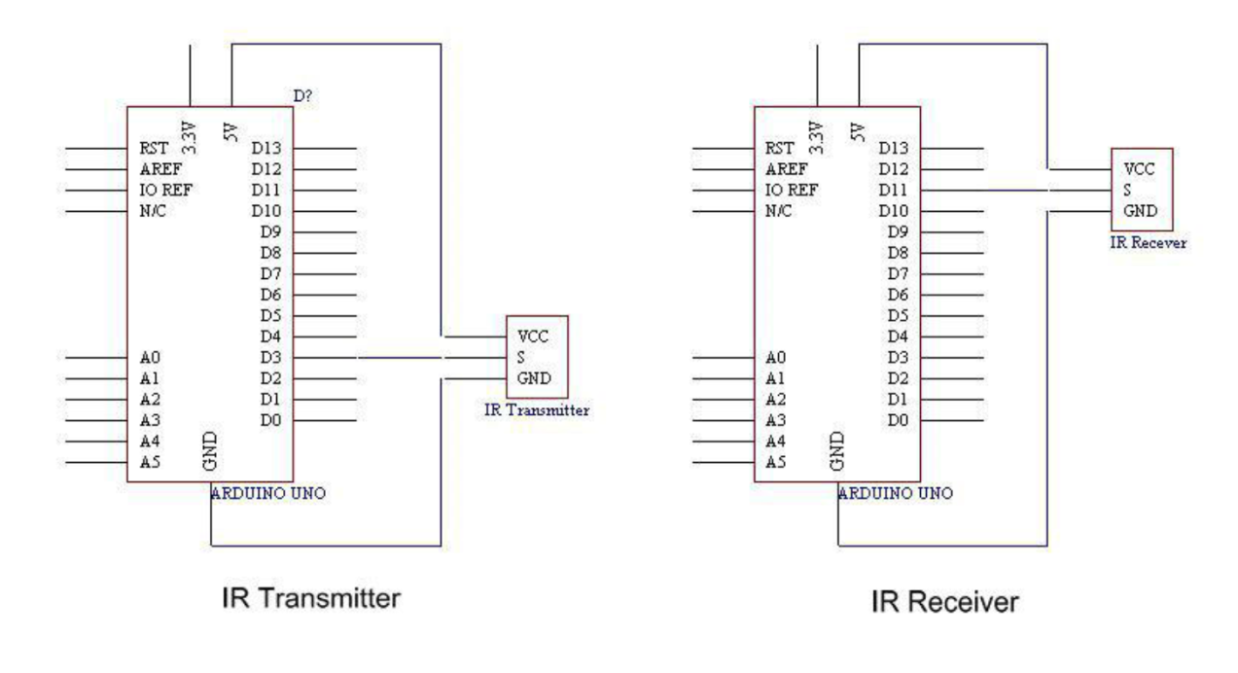

**Step 2:** Connect circuit as shown in the following photo:

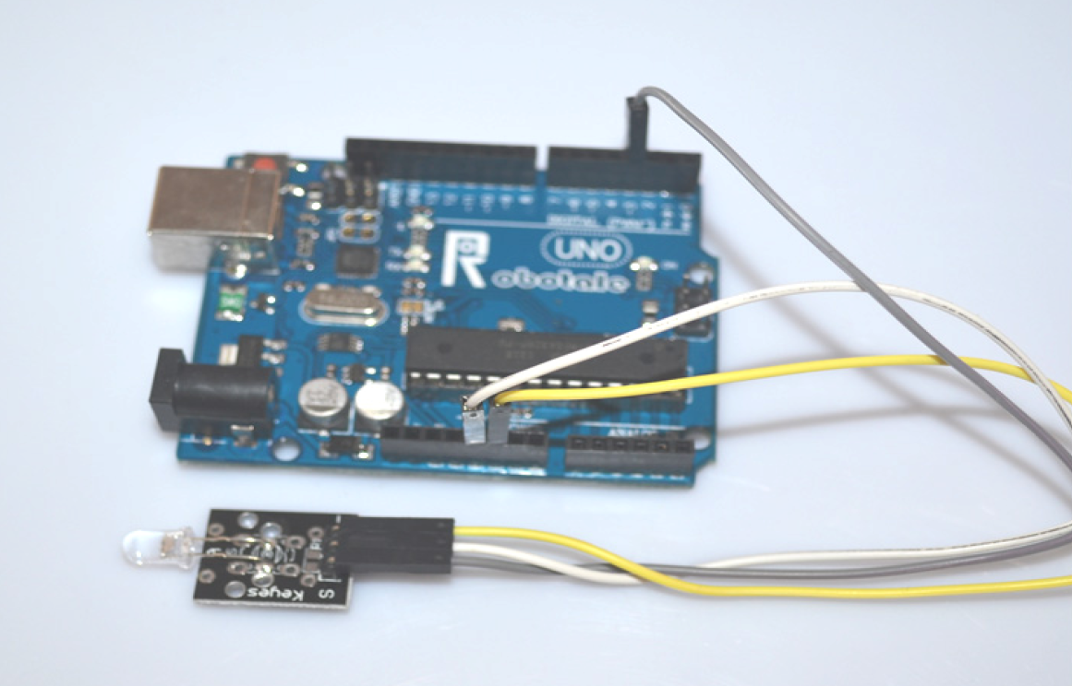

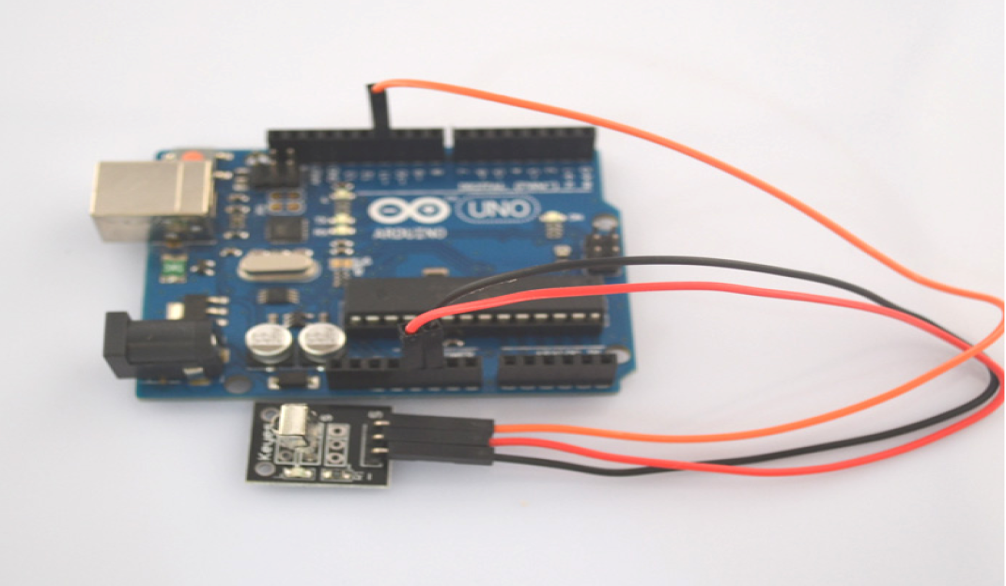

**Step 3:** Program (please refer to the example code on the CD or official website)

**Step 4:** Compile the program

**Step 5:** Burn the program into RobotLinking Uno board

**Step 6:** Open the TOOL→Serial Monitor, and we can see the data as below:

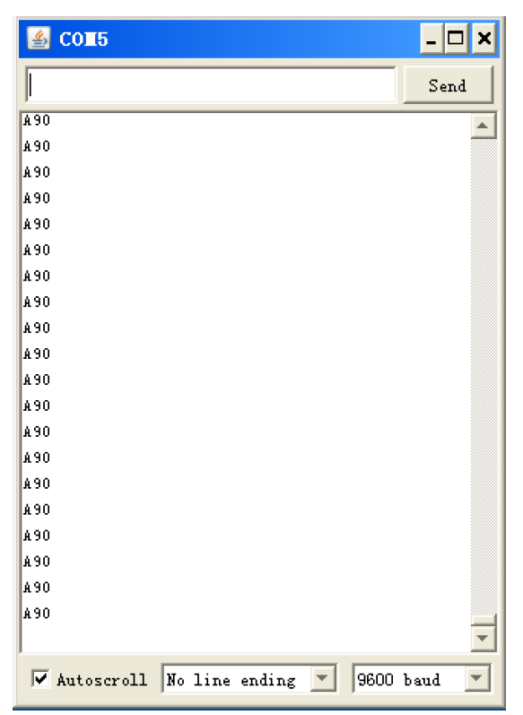 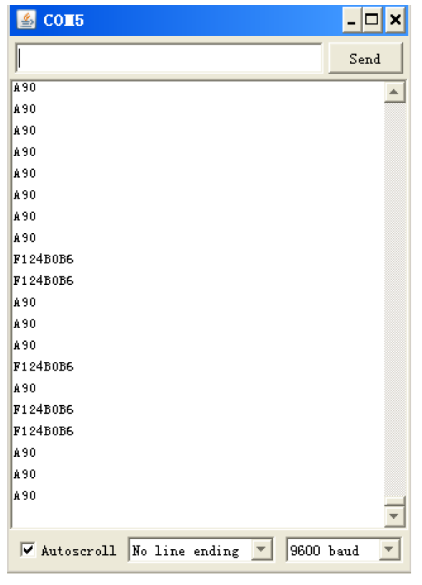

## Experimental Summary

The reason that we feel infrared is a magical thing is because we can't see and touch the infrared. But it doesn't matter, the most important thing is we can control it and make it serve us, in fact, we are even more amazing. If you feel as though you're struggling, check out our video tutorials on [www.RobotLinking.com](http://www.sunfounder.com/) or ask us questions on our forum.

# Lesson 6 PASSIVE BUZZER MODULE

## Introduction

In this experiment, we will learn how to use passive buzzer module.

With the Arduino we can complete a lot of interactive work, commonly what we used is the light shows. And we has been use the LED small lights in the experiment before. In this experiment we will make the circuit having noise. The common components that can make sound are buzzer and speakers. Compared to the speaker, buzzer is more simple and easy to use so in this experiment we adopts the buzzer.

## Components

* 1 * RobotLinking Uno board
* 1 * USB cable
* 1 * Passive buzzer module
* Dupont wires(Female to Male)

## Principle

## Function of buzzer: Voice device of the computer, printer, copier, alarm, electronic toys, automotive electronic equipment, telephone, timer and other electronic products

## The classification of the buzzer: buzzer is mainly divided into piezoelectric buzzer and magnetic buzzer.

## The circuit graphic symbol of buzzer: the letter "H" or "HA".

. 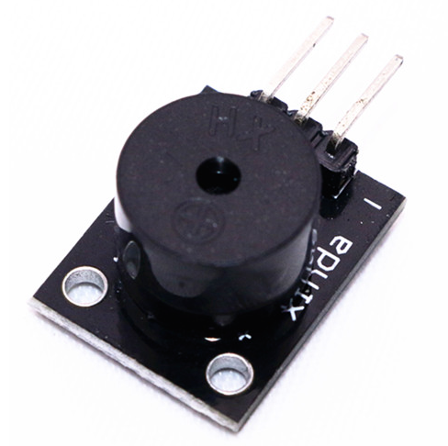

## Experimental Procedures

## Step 1: Connect circuit as shown in the following photo:

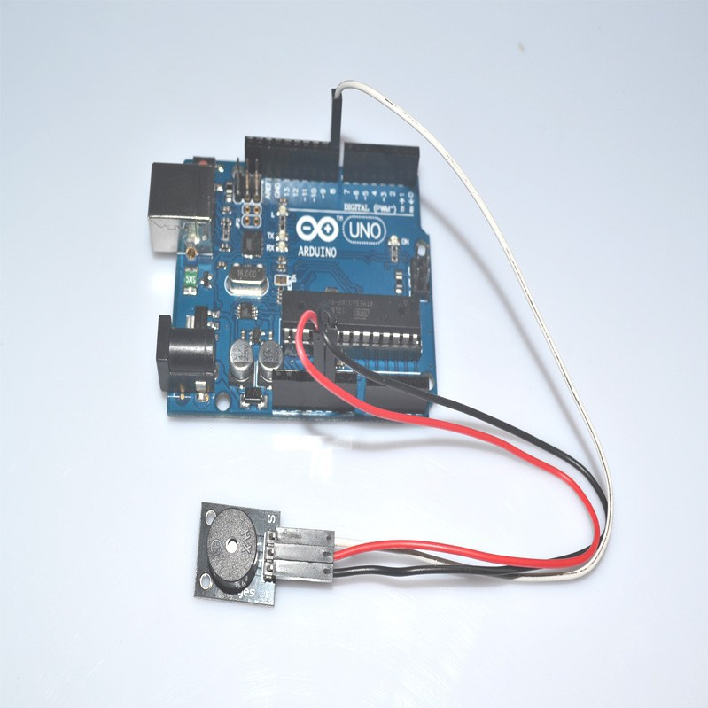

**Step 2:** Program (please refer to the example code on the CD or official website)

**Step 3:** Compile the program

**Step 4:** Burn the program into RobotLinking Uno board

## Experimental Summary

Passive buzzer module are a very simple, very practical technology that is surprisingly easy to master. If you feel as though you're struggling, check out our video tutorials on [www.RobotLinking.com](http://www.sunfounder.com/) or ask us questions on our forum.

# Lesson 7 LASER MODULE

## Introduction

In this experiment, we will learn how to use laser module.

## Components

* 1 * RobotLinking Uno board
* 1 * USB cable
* 1 * Laser module
* Dupont wires(Female to Male)

## Principle

. 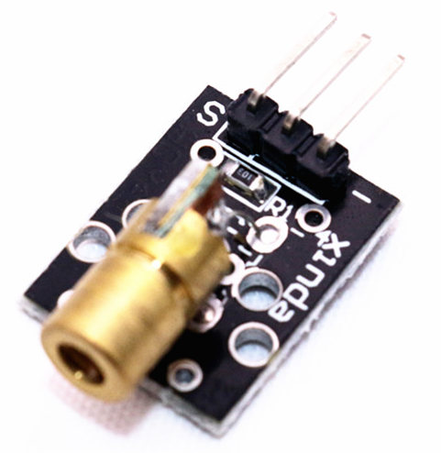

## Experimental Procedures

## Step 1: Connect circuit as shown in the following photo:

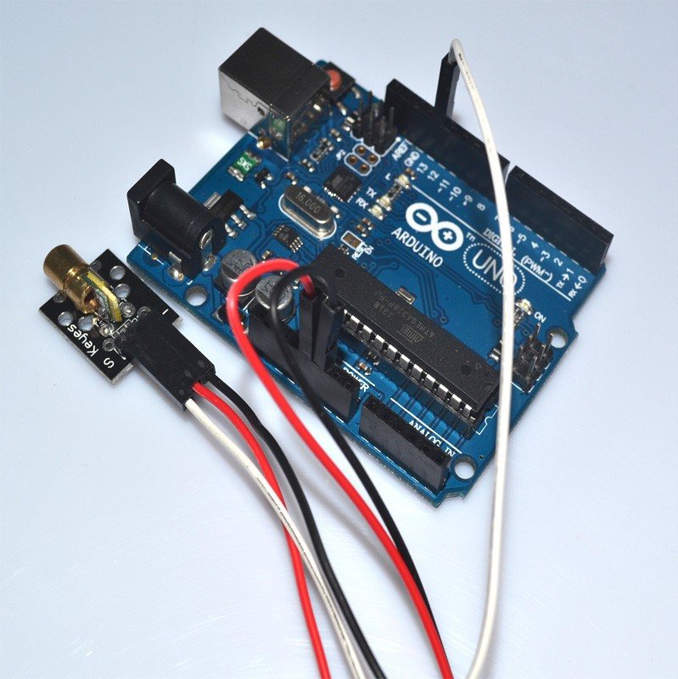

**Step 2:** Program (please refer to the example code on the CD or official website)

**Step 3:** Compile the program

**Step 4:** Burn the program into RobotLinking Uno board

## Experimental Summary

Laser module are a very simple, very practical technology that is surprisingly easy to master. If you feel as though you're struggling, check out our video tutorials on [www.RobotLinking.com](http://www.sunfounder.com/) or ask us questions on our forum.

# Lesson 8 SMD RGB MODULE AND RGB MODULE

## Introduction

In this experiment, we will learn how to use SMD RGB module and RGB module.

Actually, the function of SMD RGB module and RGB module are almost the same. But we can choose the shape we like or we need.

SMD RGB LED module and RGB module are made from a patch of full-color LED. By adjusting the voltage input of R, G, B pins, we can adjust the strengt of the three primary colors (red/blue/green) so as to implementation result of full color melange effect.

## Components

* 1 * RobotLinking Uno board
* 1 * USB cable
* 1 * SMD RGB module
* 1 * RGB module
* Dupont wires(Female to Male)

## Principle

## RGB tricolor connect to current-limiting resistance to prevent burn out

## PWM adjust the mixed of three primary colors so that we can have different colors

## Working voltage: 5v

## The LED drive mode: Common cathode

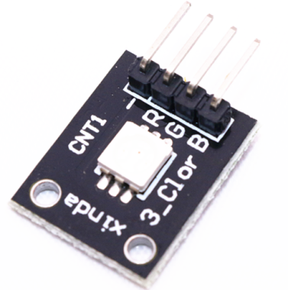 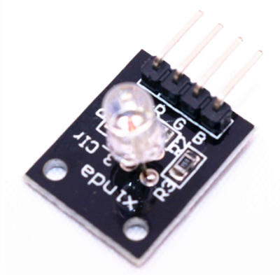

## Experimental Procedures

## Step 1: Connect circuit as shown in the following photo:

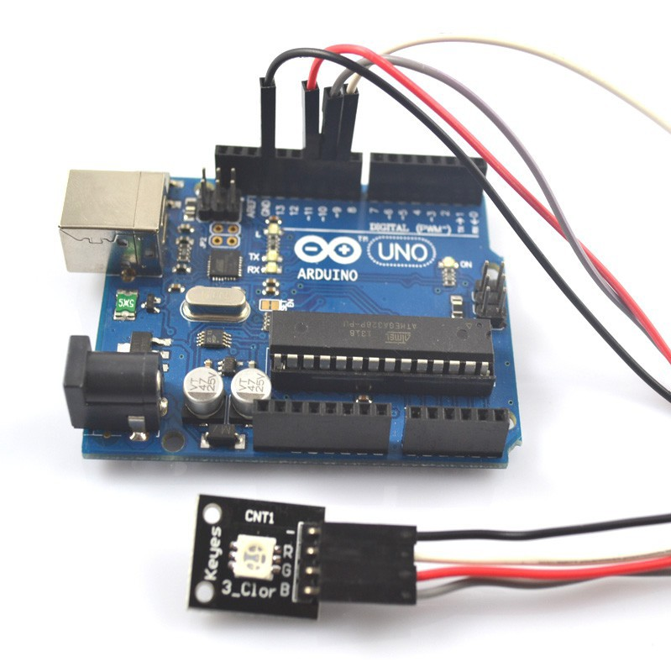

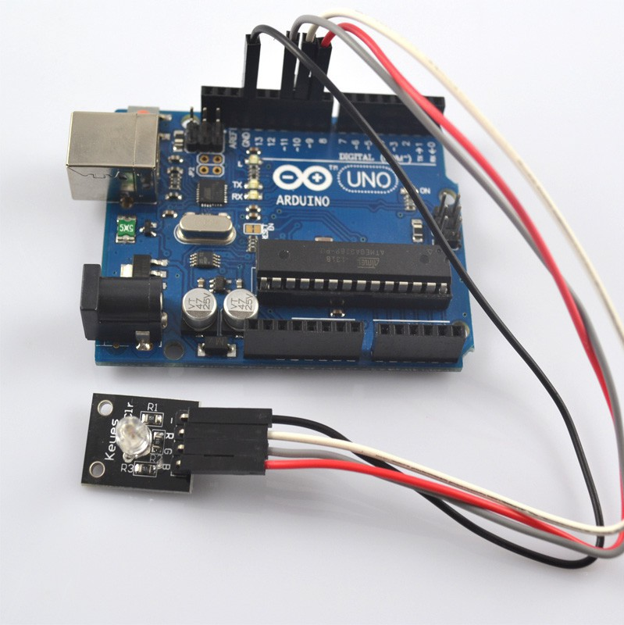

**Step 2:** Program (please refer to the example code on the CD or official website)

**Step 3:** Compile the program

**Step 4:** Burn the program into RobotLinking Uno board

## Experimental Summary

These two module are a very simple, very practical technology that is surprisingly easy to master. If you feel as though you're struggling, check out our video tutorials on [www.RobotLinking.com](http://www.sunfounder.com/) or ask us questions on our forum.

# Lesson 9 TEMP AND HUMIDITY MODULE

## Introduction

In this tutorial we will learn how to use a DHT11 Temperature and Humidity Sensor.

It’s accurate enough for most projects that need to keep track of humidity and temperature readings.

Again we will be using a Library specifically designed for these sensors that will make our code short and easy to write.

## Components

* 1 * RobotLinking Uno board
* 1 * USB cable
* 1 * temp and humidity module
* Dupont wires(Female to Male)

## Principle

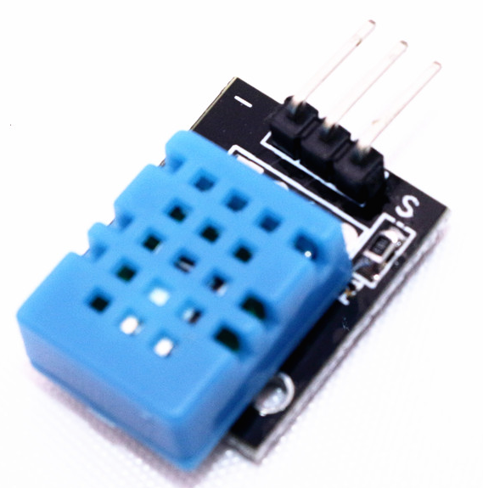

## Experimental Procedures

## Step 1: Connect circuit as shown in the following photo:

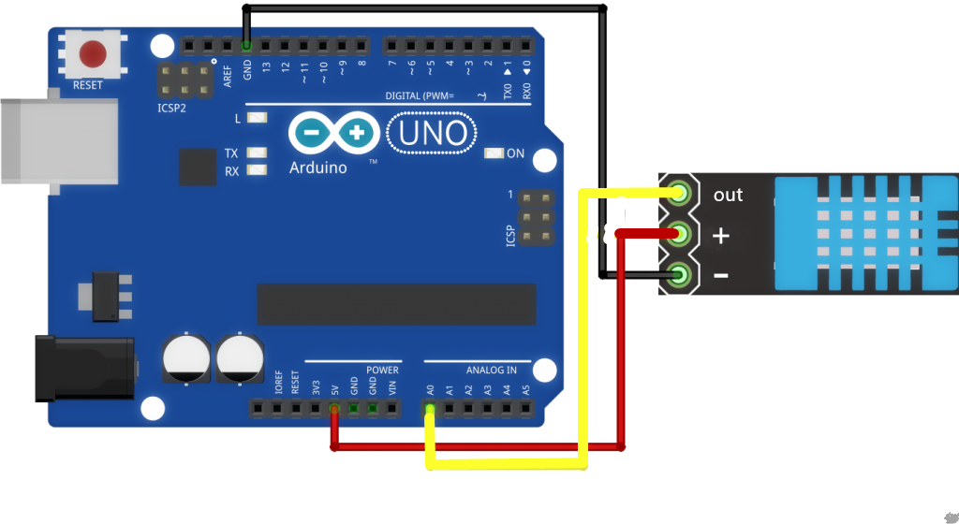

As you can see we only need 3 connections to the sensor, since one of the pin is not used.

The connection are : Voltage, Ground and Signal which can be connected to any Analog Pin on our UNO.

**Step 2:** Once you have the library, just go ahead and extract it to the Library folder inside your Arduino IDE software folder.

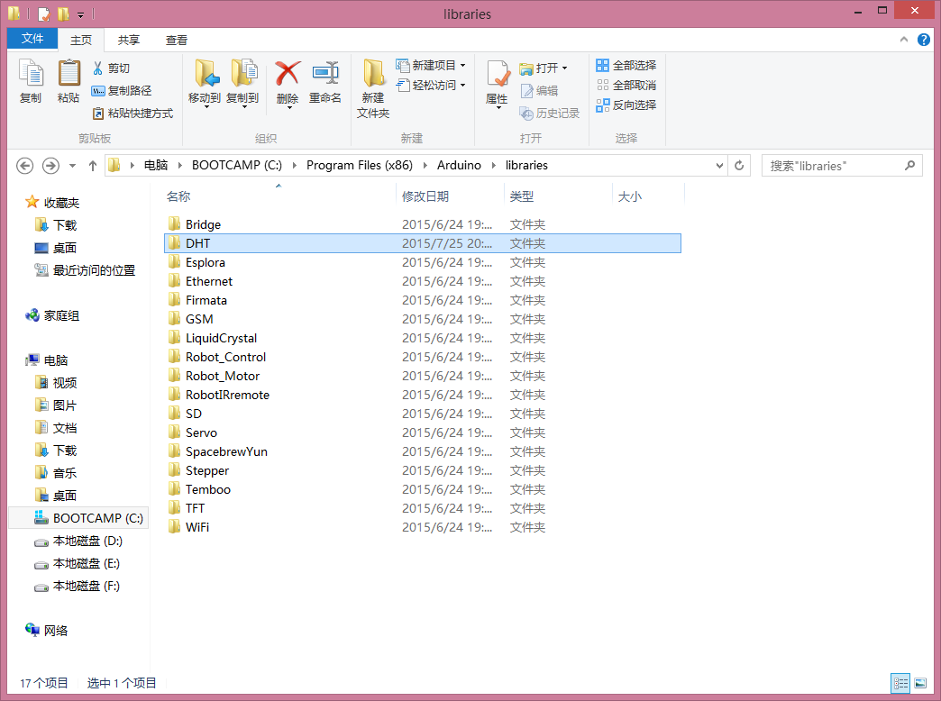

**Step 3:** Program (please refer to the example code on the CD or official website)

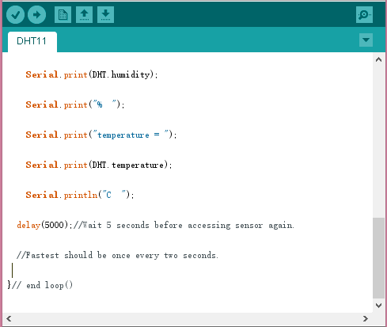

**Step 3:** Compile the program

**Step 4:** Burn the program into RobotLinking Uno board

**Step 5:** Open the toll → Serial Monitor, then you can see the humidity and temperature.

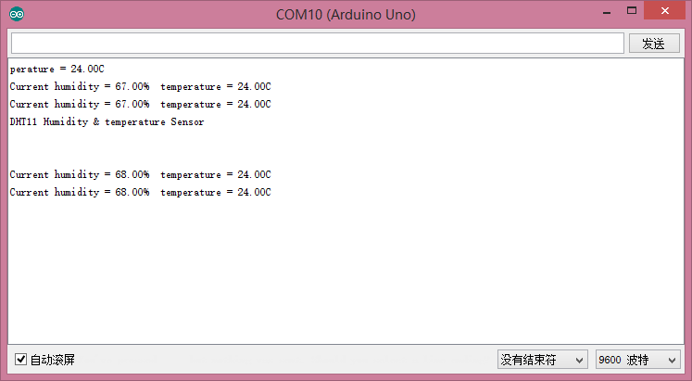

## Experimental Summary

Temp and humidity module are a very simple, very practical technology that is surprisingly easy to master. If you feel as though you're struggling, check out our video tutorials on [www.RobotLinking.com](http://www.sunfounder.com/) or ask us questions on our forum.

# Lesson 10 LIGHT BLOCKING MODULE

## Introduction

In this experiment, we will learn how to use light blocking module.

## Components

* 1 * RobotLinking Uno board
* 1 * USB cable
* 1 * light blocking module
* Dupont wires(Female to Male)

## Principle

light blocking module and number 13 port have the built-in LED simple circuit. To produce a switch flasher, we can use connect the digital port 13 to the built-in LED and connect the switch module S port to number 3 port of RobotLinking Uno board. When the switch sensing, LED twinkle light to the switch signal.

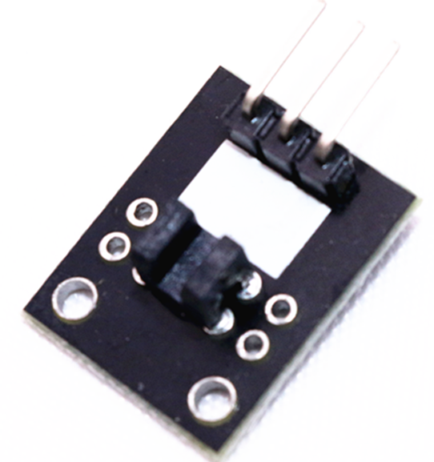

## Experimental Procedures

**Step 1:** Connect circuit as shown in the following photo:

The power cord, ground wire and S port of switch module connected to the Arduino board experiment of +5v, GND and 3 port.

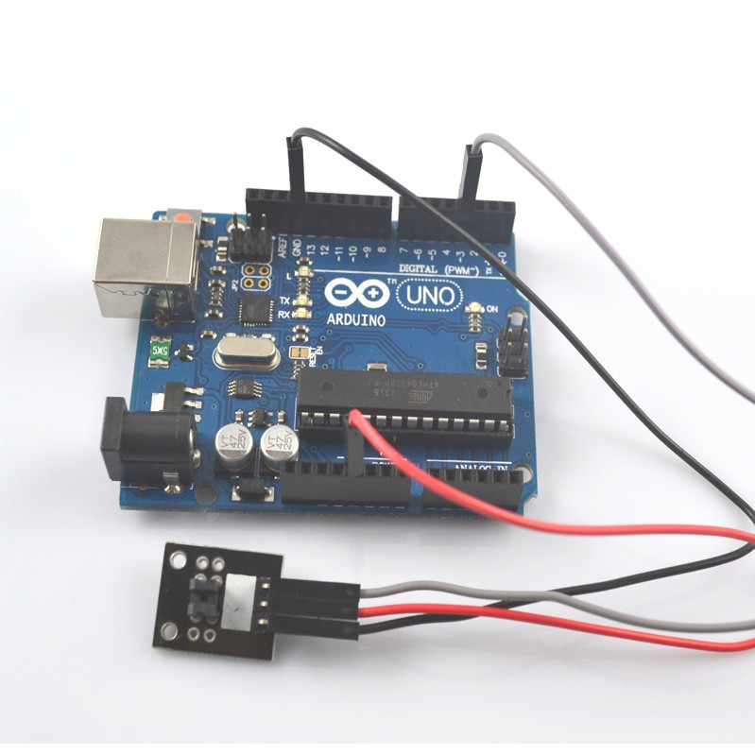

**Step 2:** Program (please refer to the example code on the CD or official website)

**Step 3:** Compile the program

**Step 4:** Burn the program into RobotLinking Uno board

## Experimental Summary

Light blocking module are a very simple, very practical technology that is surprisingly easy to master. If you feel as though you're struggling, check out our video tutorials on [www.RobotLinking.com](http://www.sunfounder.com/) or ask us questions on our forum.

# Lesson 11 TILT SWITCH MODULE

## Introduction

In this experiment, we will learn how to use tilt switch module.

## Components

* 1 * RobotLinking Uno board
* 1 * USB cable
* 1 * tilt switch module
* Dupont wires(Female to Male)

## Principle

Tilt switch module and number 13 port have the built-in LED simple circuit. To produce a switch flasher, we can use connect the digital port 13 to the built-in LED and connect the tilt switch module S port to number 3 port of RobotLinking Uno board. When the tilt switch sensing, LED twinkle light to the switch signal.

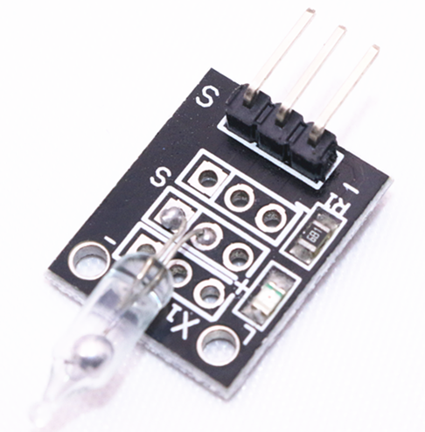

## Experimental Procedures

**Step 1:** Connect circuit as shown in the following photo:

The power cord, ground wire and S port of switch module connected to the Arduino board experiment of +5v, GND and 3 port.

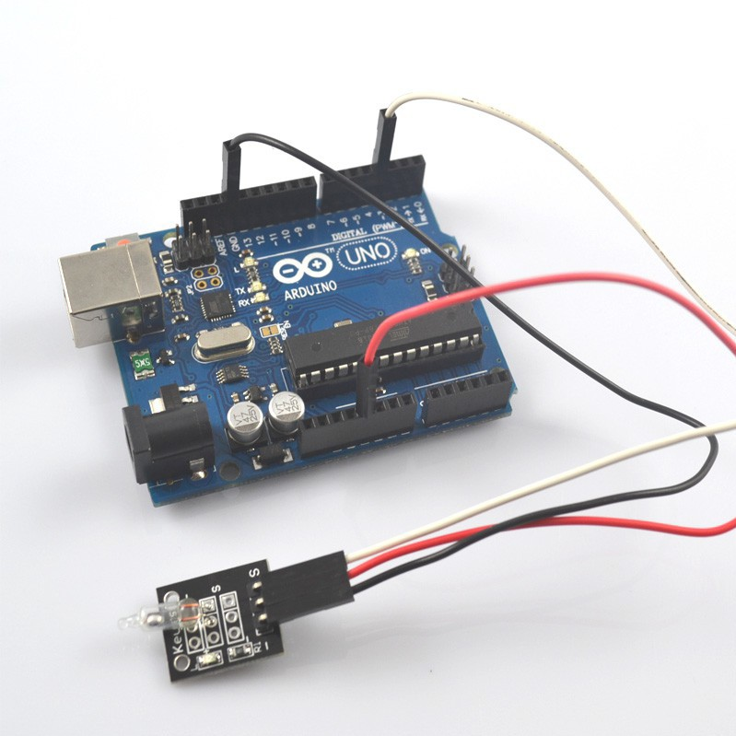

**Step 2:** Program (please refer to the example code on the CD or official website)

**Step 3:** Compile the program

**Step 4:** Burn the program into RobotLinking Uno board

## Experimental Summary

Tilt switch module are a very simple, very practical technology that is surprisingly easy to master. If you feel as though you're struggling, check out our video tutorials on [www.RobotLinking.com](http://www.sunfounder.com/) or ask us questions on our forum.

# Lesson 12 BALL SWITCH MODULE

## Introduction

In this experiment, we will learn how to use ball switch module.

## Components

* 1 * RobotLinking Uno board
* 1 * USB cable
* 1 * ball switch module
* Dupont wires(Female to Male)

## Principle

Ball switch module and number 13 port have the built-in LED simple circuit. To produce a switch flasher, we can use connect the digital port 13 to the built-in LED and connect the switch module S port to number 3 port of RobotLinking Uno board. When the switch sensing, LED twinkle light to the switch signal.

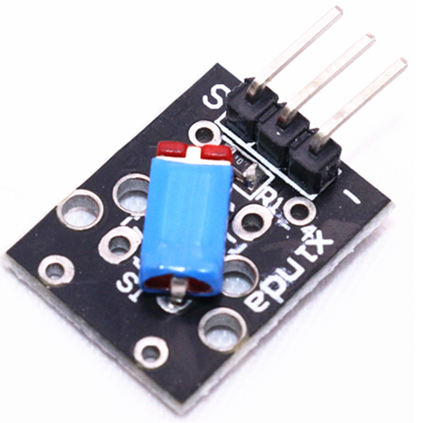

## Experimental Procedures

**Step 1:** Connect circuit as shown in the following photo:

The power cord, ground wire and S port of switch module connected to the Arduino board experiment of +5v, GND and 3 port.

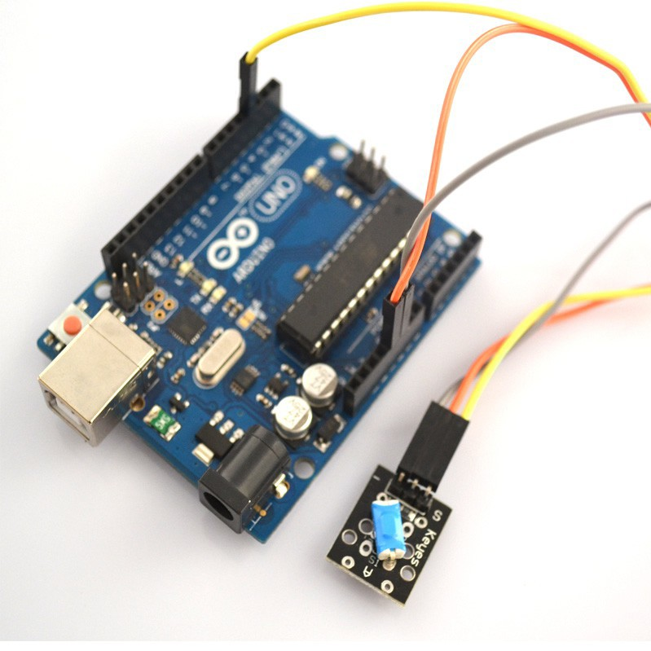

**Step 2:** Program (please refer to the example code on the CD or official website)

**Step 3:** Compile the program

**Step 4:** Burn the program into RobotLinking Uno board

## Experimental Summary

Ball switch module are a very simple, very practical technology that is surprisingly easy to master. If you feel as though you're struggling, check out our video tutorials on [www.RobotLinking.com](http://www.sunfounder.com/) or ask us questions on our forum.

# Lesson 13 REED SWITCH AND MINI REED SWITCH MODULE

## Introduction

In this experiment, we will learn how to use reed switch and mini reed switch module.

## Components

* 1 * RobotLinking Uno board
* 1 * USB cable
* 1 * reed switch
* 1 * mini reed switch
* Dupont wires(Female to Male)

## Principle

reed switch and mini switch module and number 13 port have the built-in LED simple circuit. To produce a switch flasher, we can use connect the digital port 13 to the built-in LED and connect the switch module S port to number 3 port of RobotLinking Uno board. When the switch sensing, LED twinkle light to the switch signal.

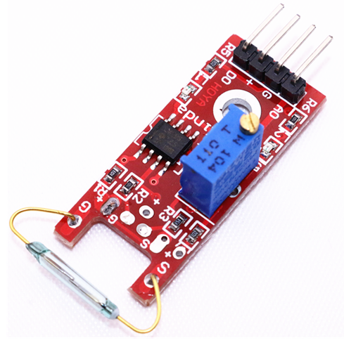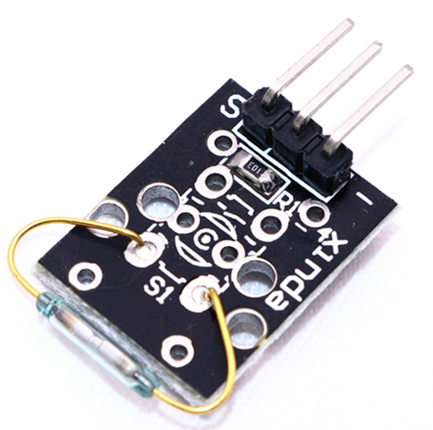

## Experimental Procedures

**Step 1:** Connect circuit as shown in the following photo:

The power cord, ground wire and S port of switch module connected to the Arduino board experiment of +5v, GND and 3 port.

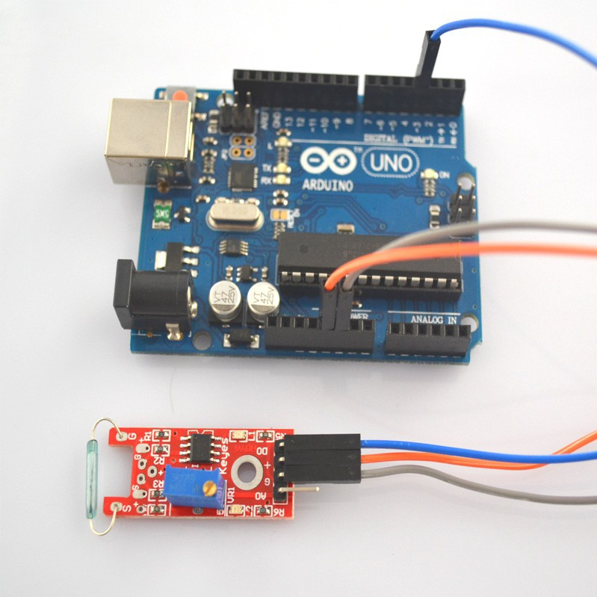

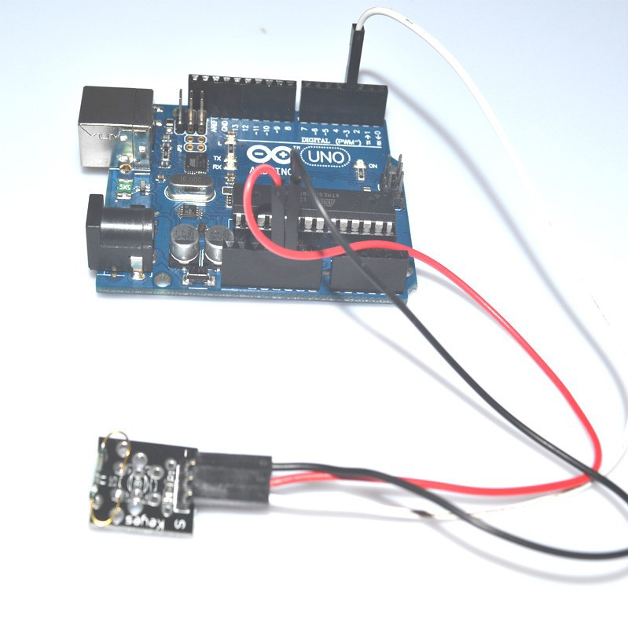

**Step 2:** Program (please refer to the example code on the CD or official website)

**Step 3:** Compile the program

**Step 4:** Burn the program into RobotLinking Uno board

## Experimental Summary

Reed switch and mini reed switch module are very simple, very practical technology that is surprisingly easy to master. If you feel as though you're struggling, check out our video tutorials on [www.RobotLinking.com](http://www.sunfounder.com/) or ask us questions on our forum.

# Lesson 14 TWO-COLOR LED MODULE AND MINI TWO-COLOR LED MODULE

## Introduction

In this experiment, we will learn how to use two-color LED module and mini two-color LED module.

## Components

* 1 * RobotLinking Uno board
* 1 * USB cable
* 1 * two-color LED module
* 1 * mini two-color LED module
* Dupont wires(Female to Male)

## Principle

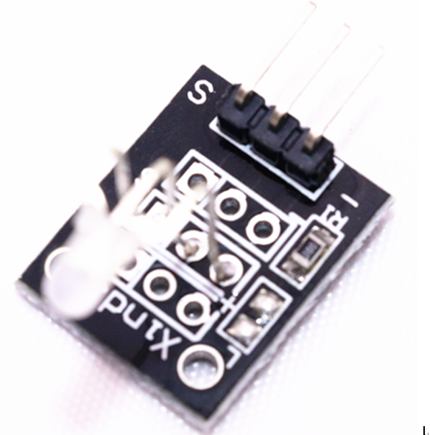 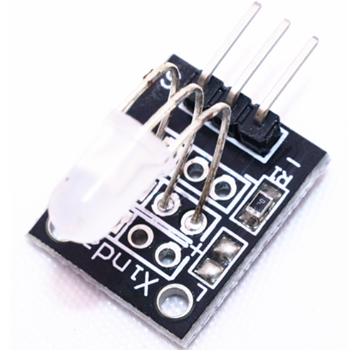

## Experimental Procedures

**Step 1:** Connect circuit as shown in the following photo:

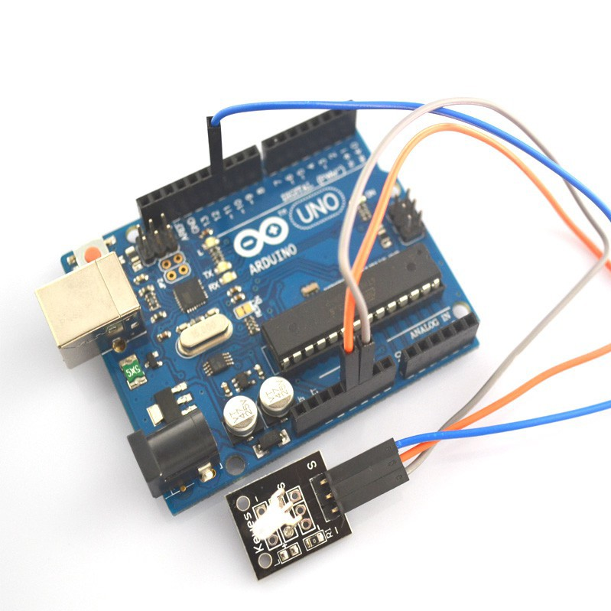

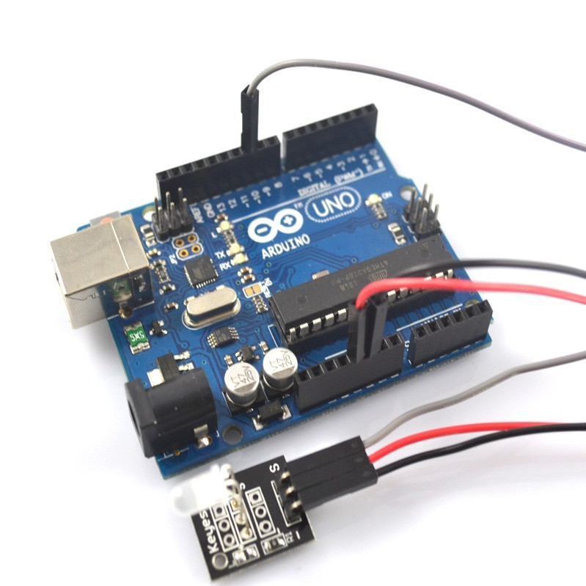

**Step 2:** Program (please refer to the example code on the CD or official website)

**Step 3:** Compile the program

**Step 4:** Burn the program into RobotLinking Uno board

## Experimental Summary

Two-color LED and mini two-color LED module are a very simple, very practical technology that is surprisingly easy to master. If you feel as though you're struggling, check out our video tutorials on [www.RobotLinking.com](http://www.sunfounder.com/) or ask us questions on our forum.

# Lesson 15 TAP MODULE

## Introduction

In this experiment, we will learn how to use tap switch module.

## Components

* 1 * RobotLinking Uno board
* 1 * USB cable
* 1 * tap module
* Dupont wires(Female to Male)

## Principle

tap switch module and number 13 port have the built-in LED simple circuit. To produce a switch flasher, we can use connect the digital port 13 to the built-in LED and connect the switch module S port to number 3 port of RobotLinking Uno board. When the switch sensing, LED twinkle light to the switch signal.

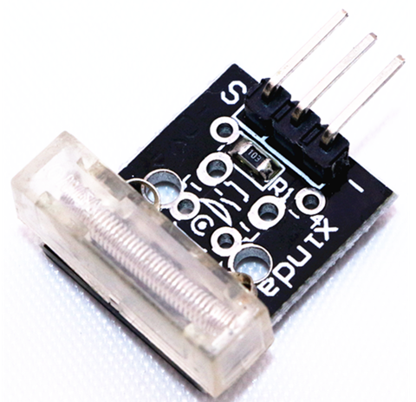

## Experimental Procedures

**Step 1:** Connect circuit as shown in the following photo:

The power cord, ground wire and S port of switch module connected to the Arduino board experiment of +5v, GND and 3 port.

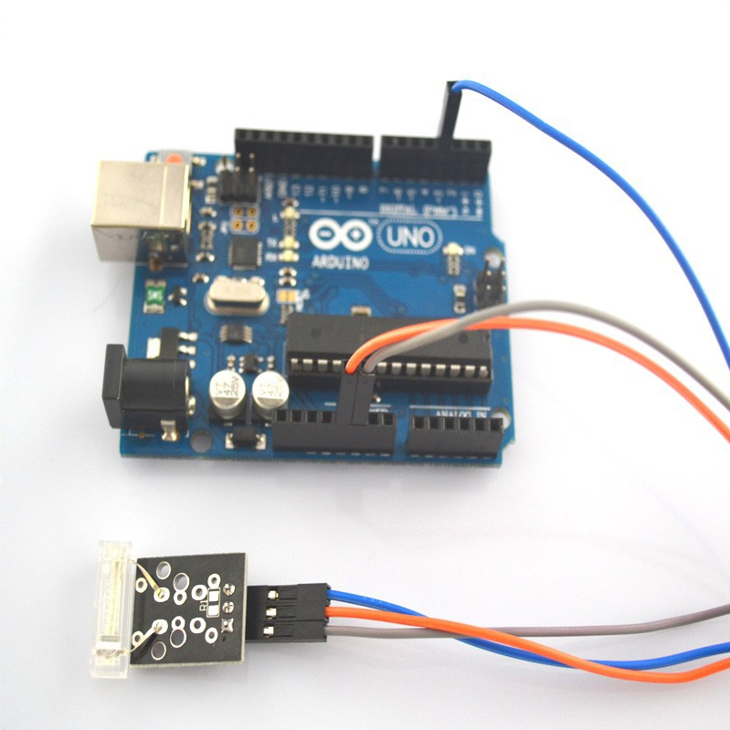

**Step 2:** Program (please refer to the example code on the CD or official website)

**Step 3:** Compile the program

**Step 4:** Burn the program into RobotLinking Uno board

## Experimental Summary

Tap switch module are a very simple, very practical technology that is surprisingly easy to master. If you feel as though you're struggling, check out our video tutorials on [www.RobotLinking.com](http://www.sunfounder.com/) or ask us questions on our forum.

# Lesson 16 DIGITAL TEMPERATURE MODULE

## Introduction

In this experiment, we will learn how to use digital temperature module.

## Components

* 1 * RobotLinking Uno board
* 1 * USB cable
* 1 * digital temperature module
* Dupont wires(Female to Male)

## Principle

tap switch module and number 13 port have the built-in LED simple circuit. To produce a temperature flasher, we can use connect the digital port 13 to the built-in LED and connect the temperature module S port to number 3 port of RobotLinking Uno board. When the temperature sensing, LED twinkle light to the module signal.

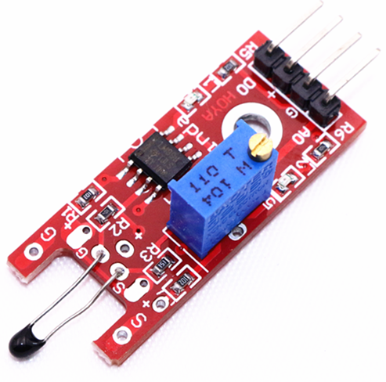

## Experimental Procedures

**Step 1:** Connect circuit as shown in the following photo:

The power cord, ground wire and S port of digital temperature module connected to the Arduino board experiment of +5v, GND and 3 port.

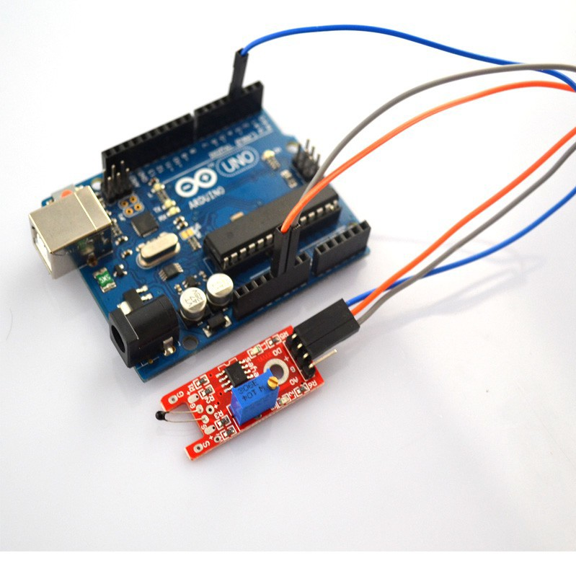

**Step 2:** Program (please refer to the example code on the CD or official website)

**Step 3:** Compile the program

**Step 4:** Burn the program into RobotLinking Uno board

## Experimental Summary

Digital temperature module are a very simple, very practical technology that is surprisingly easy to master. If you feel as though you're struggling, check out our video tutorials on [www.RobotLinking.com](http://www.sunfounder.com/) or ask us questions on our forum.

# Lesson 17 FLAME SENSOR MODULE

## Introduction

In this experiment, we will learn how to use the flame sensor module.

## Components

* 1 * RobotLinking Uno board
* 1 * USB cable
* 1 * flame sensor module
* Dupont wires(Female to Male)

## Principle

Flame sensor module and number 13 port have the built-in LED simple circuit. To produce a flame sensing flasher, we can use connect the digital port 13 to the built-in LED and connect the flame sensor module S port to number 3 port of RobotLinking Uno board. When the flame sensor module sensing fire, LED twinkle light to the module signal.

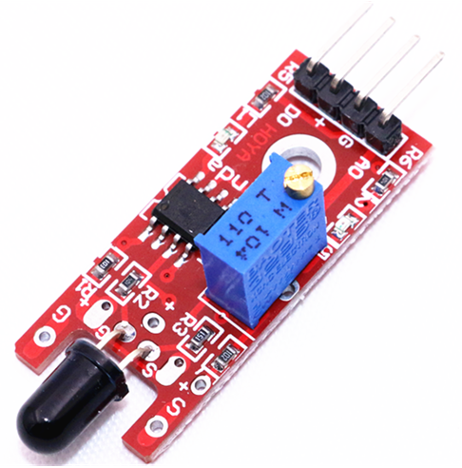

## Experimental Procedures

**Step 1:** Connect circuit as shown in the following photo:

The power cord, ground wire and S port of flame sensor module connected to the Arduino board experiment of +5v, GND and 3 port.

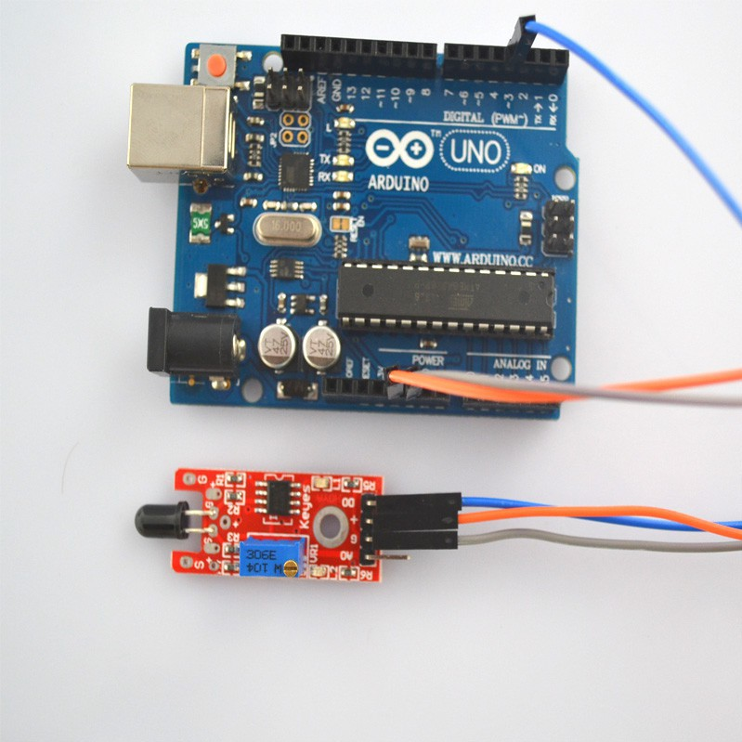

**Step 2:** Program (please refer to the example code on the CD or official website)

**Step 3:** Compile the program

**Step 4:** Burn the program into RobotLinking Uno board

## Experimental Summary

Flame sensor module are a very simple, very practical technology that is surprisingly easy to master. If you feel as though you're struggling, check out our video tutorials on [www.RobotLinking.com](http://www.sunfounder.com/) or ask us questions on our forum.

# Lesson 18 MENTAL TOUCH MODULE

## Introduction

In this experiment, we will learn how to use the mental touch module.

## Components

* 1 * RobotLinking Uno board
* 1 * USB cable
* 1 * mental touch module
* Dupont wires(Female to Male)

## Principle

Touch module and number 13 port have the built-in LED simple circuit. To produce a mental touch sensing flasher, we can use connect the digital port 13 to the built-in LED and connect the mental touch module S port to number 3 port of RobotLinking Uno board. When the touch module sensing touch, LED twinkle light to the module signal.

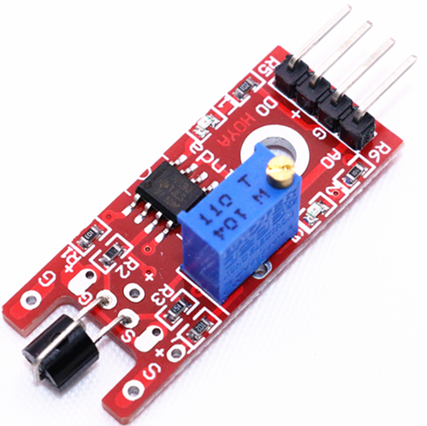

## Experimental Procedures

**Step 1:** Connect circuit as shown in the following photo:

The power cord, ground wire and S port of mental touch module connected to the Arduino board experiment of +5v, GND and 3 port.

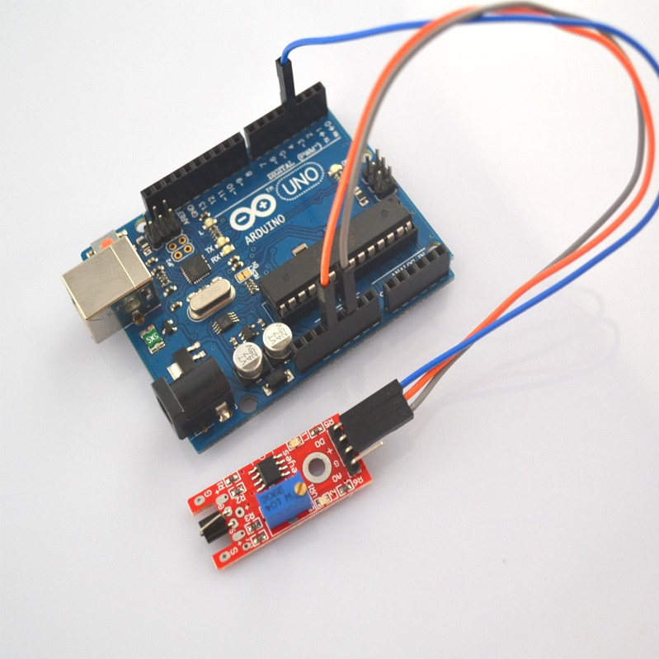

**Step 2:** Program (please refer to the example code on the CD or official website)

**Step 3:** Compile the program

**Step 4:** Burn the program into RobotLinking Uno board

## Experimental Summary

Mental touch module are a very simple, very practical technology that is surprisingly easy to master. If you feel as though you're struggling, check out our video tutorials on [www.RobotLinking.com](http://www.sunfounder.com/) or ask us questions on our forum.

# Lesson 19 ANALOG TEMP MODULE

## Introduction

In this experiment, we will learn how to use the analog temp module.

## Components

* 1 * RobotLinking Uno board
* 1 * USB cable
* 1 * analog temp module
* Dupont wires(Female to Male)

## Principle

The module is based on a thermistor (resistance varies with temperature change and environment), the working principle of the real time perception surrounding the change of environmental temperature, we send the data to the Arduino analog I/o, we just came through a simple programming can convert the sensor output data to degrees Celsius temperature, and shows that is convenient to use, effective, to widely used in gardening, home alarm system and other devices.

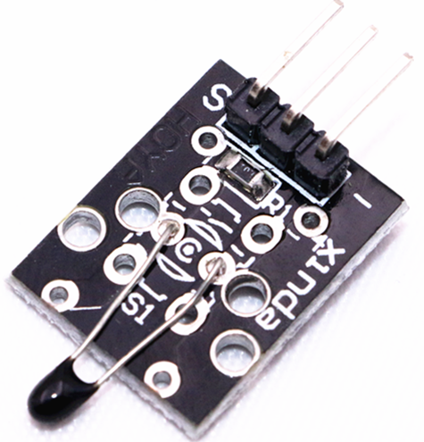

## Experimental Procedures

**Step 1:** The corresponding schematic diagram is as follows:

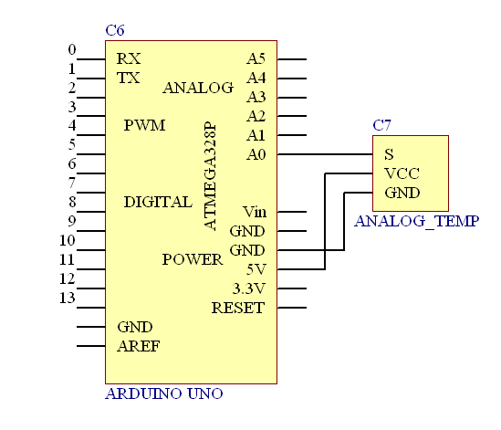

**Step 2:** Connect circuit as shown in the following photo:

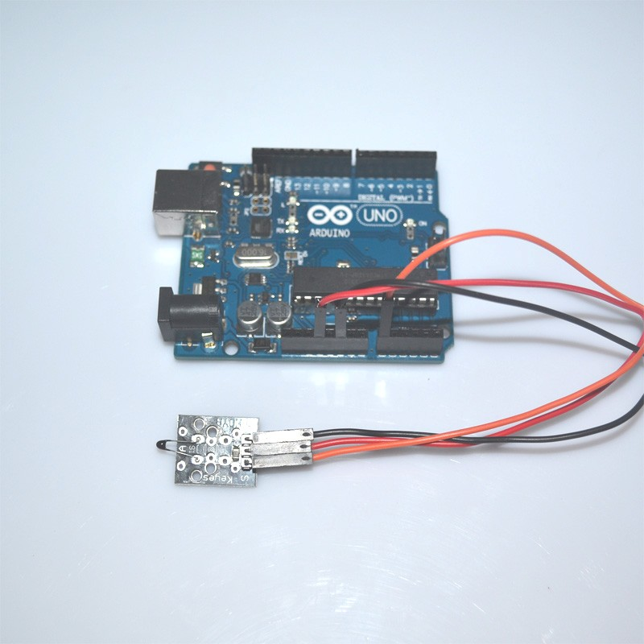

**Step 3:** Program (please refer to the example code on the CD or official website)

**Step 4:** Compile the program

**Step 5:** Burn the program into RobotLinking Uno board

**Step 6:** Open the TOOL→Serial Monitor, and we can see the data as below:

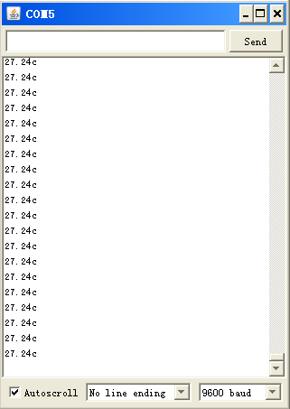

## Experimental Summary

ANALOG TEMP module are a very simple, very practical technology that is surprisingly easy to master. If you feel as though you're struggling, check out our video tutorials on [www.RobotLinking.com](http://www.sunfounder.com/) or ask us questions on our forum.

# Lesson 20 PHOTORESISTOR MODULE

## Introduction

In this experiment, we will learn how to use the photoresistor module.

Photoresistor is very common in our daily life. it is mainly used in intelligent switch so as to bring convenience to our life. At the same time, in our daily life, we also use it in electronic design. So in order to use it in a better, we provide the corresponding modules to help us to use it more conveniently and efficiently.

## Components

* 1 * RobotLinking Uno board
* 1 * USB cable
* 1 * photoresistor module
* Dupont wires(Female to Male)

## Principle

Photosensitive resistance is photosensitive semiconductor device. In addition to high sensitivity, fast response, spectral characteristics and same r value, it can maintain a high level of stability and reliability in the high temperature, wet and bad environment. It can be widely apply in the camera, solar garden lamp, lawn lamp, counterfeit detector, quartz clock, music cup, gift boxes, mini night light, street lamp automatic switch and all kinds of electric toys, electric lighting, lamps and lanterns, and other areas of the light automatically on-off controller area.

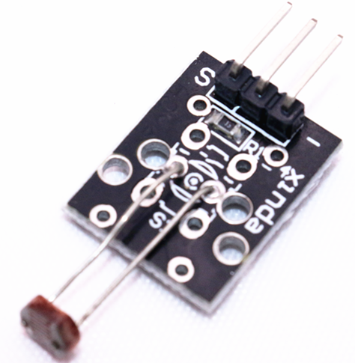

## Experimental Procedures

**Step 1:** The corresponding schematic diagram is as follows:

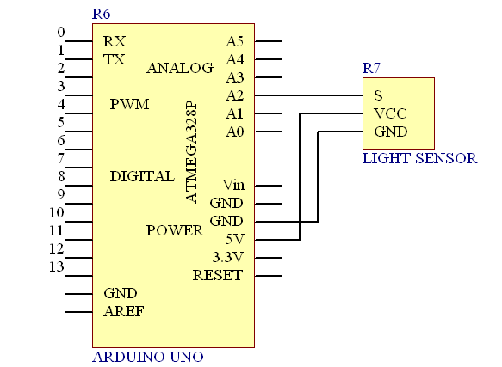

**Step 2:** Connect circuit as shown in the following photo:

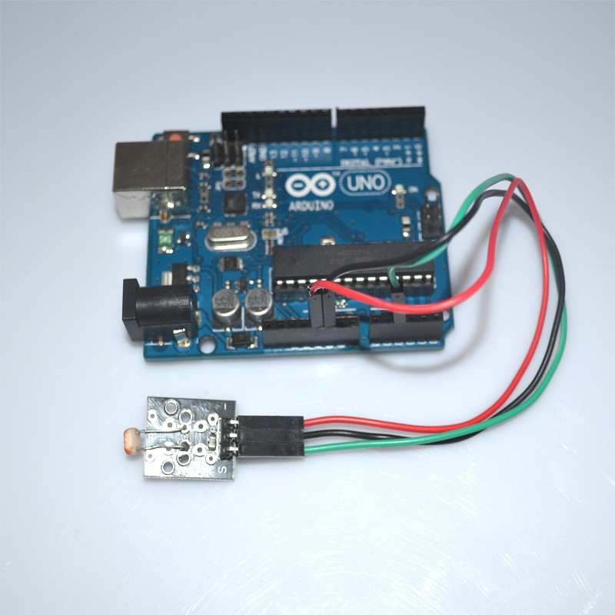

**Step 3:** Program (please refer to the example code on the CD or official website)

**Step 4:** Compile the program

**Step 5:** Burn the program into RobotLinking Uno board

**Step 6:** Open the TOOL→Serial Monitor, and we can see the data as below:

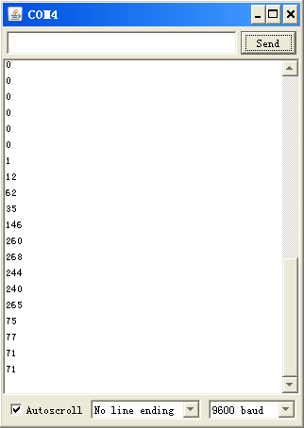

## Experimental Summary

In the test, we only read the output analog voltage value of photoresistor module. In the test results, we will find that when there is lighting, high voltage output equivalently of switch on, when there is no light, low voltage equivalently of switch off. This is what we can use this in practice.

If you feel as though you're struggling, check out our video tutorials on [www.RobotLinking.com](http://www.sunfounder.com/) or ask us questions on our forum.

# Lesson 21 7 COLOR FLASH LED MODULE

## Introduction

In this experiment, we will learn how to use the 7 color flash LED module.

## Components

* 1 * RobotLinking Uno board
* 1 * USB cable
* 1 * 7 color flash LED module
* Dupont wires(Female to Male)

## Principle

the product type: light-emitting diodes

product model: b4pnyg YB-3120-PM

the product shape: straight plug type 5 mm round hair light diode

light color: pink yellow green (high brightness)

lens type: white mist

standard forward voltage: 3.0-4.5V

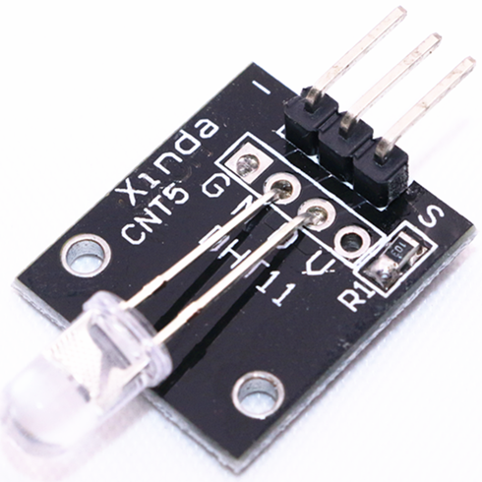

## Experimental Procedures

**Step 1:** Connect circuit as shown in the following photo:

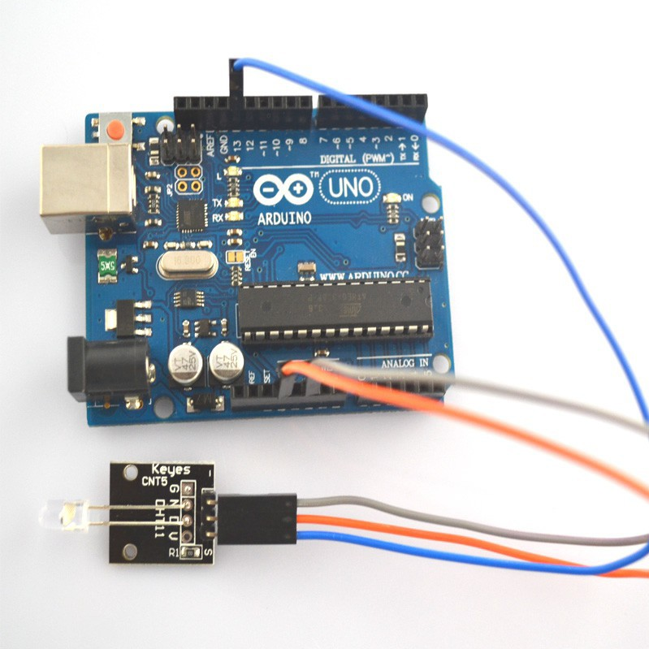

**Step 2:** Program (please refer to the example code on the CD or official website)

**Step 3:** Compile the program

**Step 4:** Burn the program into RobotLinking Uno board

## Experimental Summary

7 color flash LED module are a very simple, very practical technology that is surprisingly easy to master. If you feel as though you're struggling, check out our video tutorials on [www.RobotLinking.com](http://www.sunfounder.com/) or ask us questions on our forum.

# Lesson 22 BIG SOUND SENSOR MODULE AND SMALL SOUND SENSOR MODULE

## Introduction

In this experiment, we will learn how to use the big sound sensor module and small sound sensor module.

## Components

* 1 * RobotLinking Uno board
* 1 * USB cable
* 1 * big sound sensor module
* 1 * small sound sensor module
* Dupont wires(Female to Male)

## Principle

Sound detection module has two output:

AO, analog output, real-time output voltage signal of microphone

DO, when the intensity of the sound to reach a certain threshold, the output high and low level signal, the threshold - sensitivity can be achieved by potentiometer adjustment period

The module features:

The installation of 3 mm screw holes

use 5 v dc power supply

have analog output

turn a threshold level of output

microphone Gao Gan degree, high sensitivity.

has a power light

the comparator output indicator light

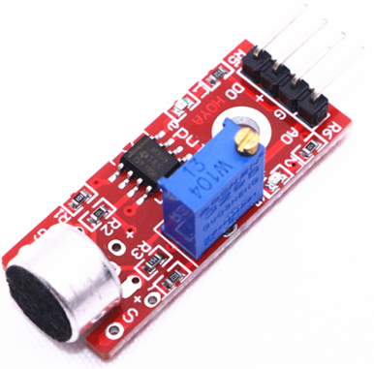

## Experimental Procedures

**Digital signal output:**

**Step 1:** Connect circuit as shown in the following photo:

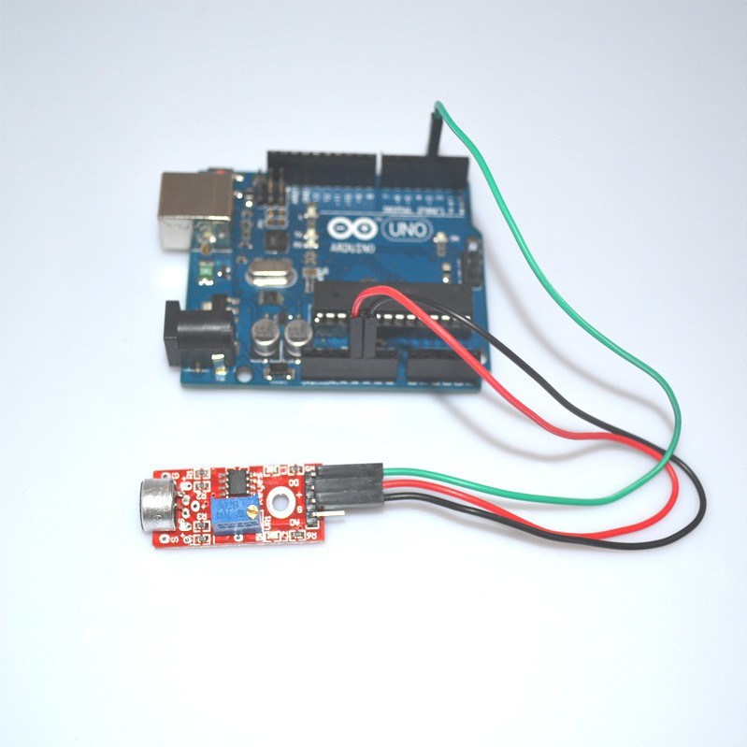

**Step 2:** Program (please refer to the example code on the CD or official website)

**Step 3:** Compile the program

**Step 4:** Burn the program into RobotLinking Uno board

**Analog signal output**

**Step 1:** Connect circuit as shown in the following photo:

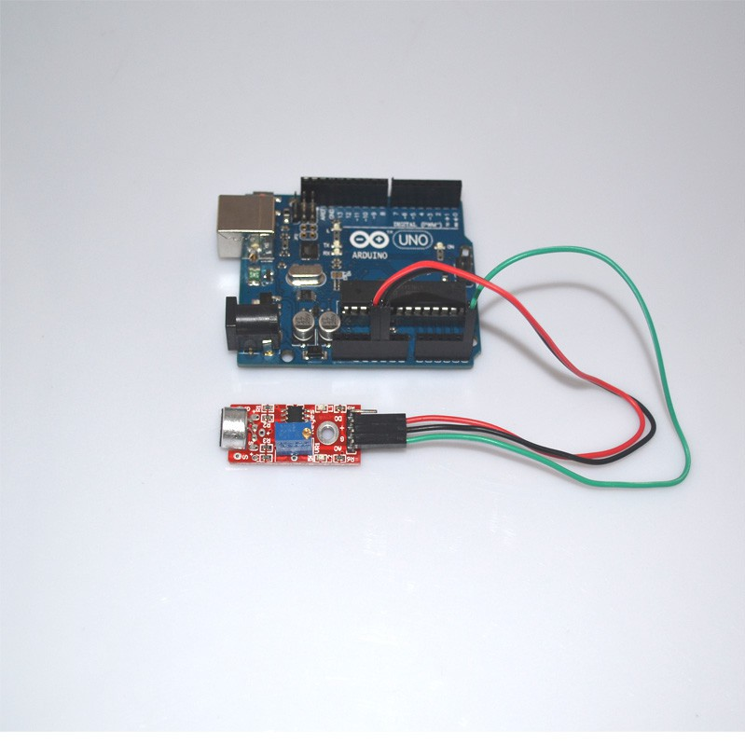

**Step 2:** Program (please refer to the example code on the CD or official website)

**Step 3:** Compile the program

**Step 4:** Burn the program into RobotLinking Uno board

**Step 5:** Open the TOOL→Serial Monitor, and we can see the data

## Experimental Summary

Big sound and small sound module are a very simple, very practical technology that is surprisingly easy to master. If you feel as though you're struggling, check out our video tutorials on [www.RobotLinking.com](http://www.sunfounder.com/) or ask us questions on our forum.

# Lesson 23 LIGHT CUP MODULE

## Introduction

In this experiment, we will learn how to use the light cup module.

## Components

* 1 * RobotLinking Uno board
* 1 * USB cable
* 2 * light cup module
* Dupont wires(Female to Male)

## Principle

## Magic light cup module is a product which can easily interact with the ARDUINO module, the principle is to use the PWM dimming, change the brightness of the two modules.Mercury switch provides digital signal, trigger PWM adjustment. through the design program, we can see the result which is similar to the effect of two cup full of light pouring to each other.

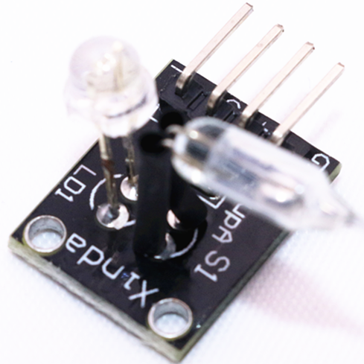

## Experimental Procedures

**Step 1:** Connect circuit as shown in the following photo:

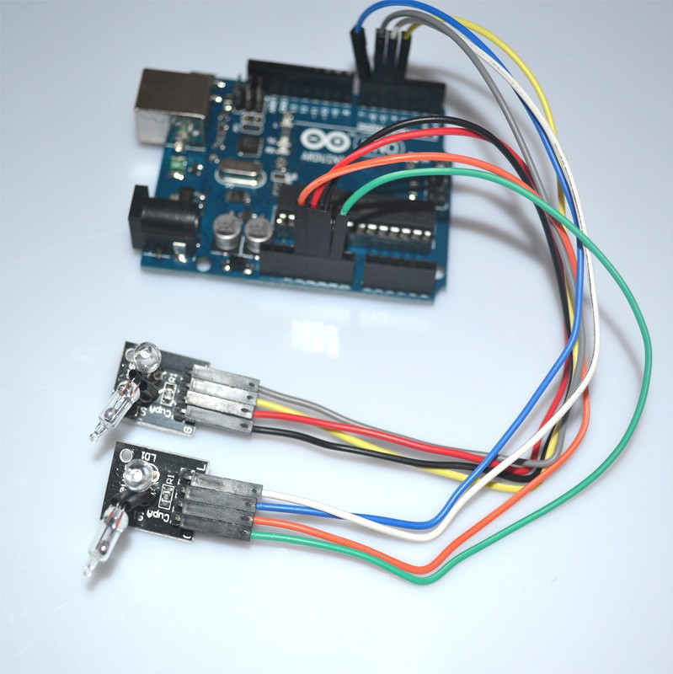

**Step 2:** Program (please refer to the example code on the CD or official website)

**Step 3:** Compile the program

**Step 4:** Burn the program into RobotLinking Uno board

## Experimental Summary

Magic light cup module are a very simple, very practical technology that is surprisingly easy to master. If you feel as though you're struggling, check out our video tutorials on [www.RobotLinking.com](http://www.sunfounder.com/) or ask us questions on our forum.

# Lesson 24 JOYSTICK MODULE

## Introduction

In this experiment, we will learn how to use the joystick module.

## Components

* 1 * RobotLinking Uno board
* 1 * USB cable
* 1 * joystick module
* Dupont wires(Female to Male)

## Principle

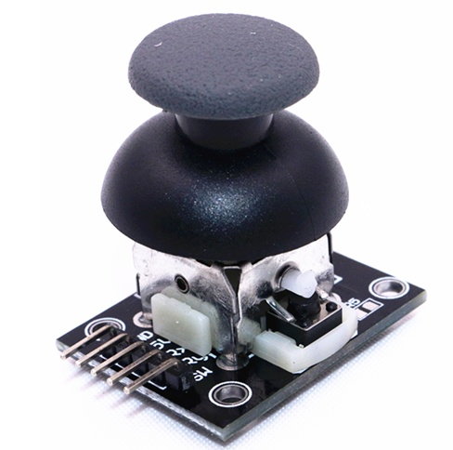

## Experimental Procedures

**Step 1:** Connect circuit as shown in the following photo:

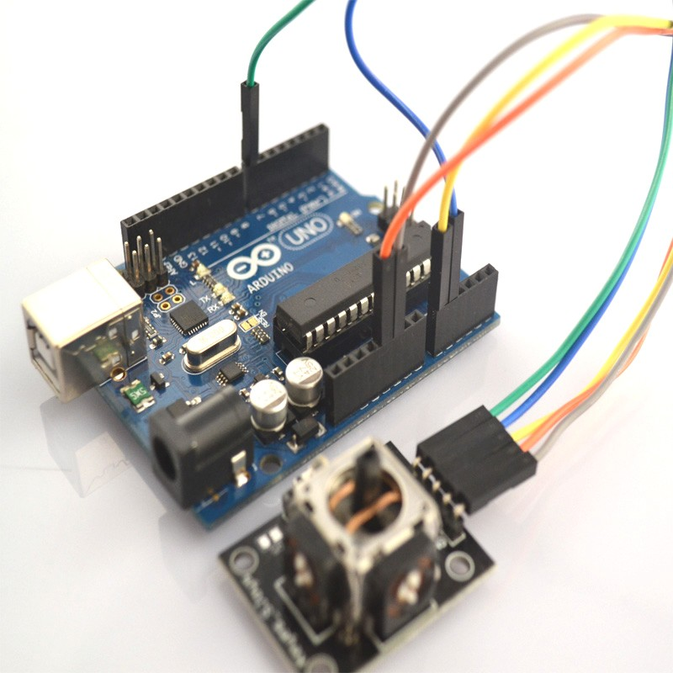

**Step 2:** Program (please refer to the example code on the CD or official website)

**Step 3:** Compile the program

**Step 4:** Burn the program into RobotLinking Uno board

**Step 5:** Open the TOOL→Serial Monitor, and we can see the data as below:



## Experimental Summary

Joystick module are a very simple, very practical technology that is surprisingly easy to master. If you feel as though you're struggling, check out our video tutorials on [www.RobotLinking.com](http://www.sunfounder.com/) or ask us questions on our forum.

# Lesson 25 LINEAR HALL AND ANALOG HALL MODULE

## Introduction

In this experiment, we will learn how to use the linear hall and analog hall module.

## Components

* 1 * RobotLinking Uno board
* 1 * USB cable
* 1 * linear hall module
* 1 * analog hall module
* Dupont wires(Female to Male)

## Principle

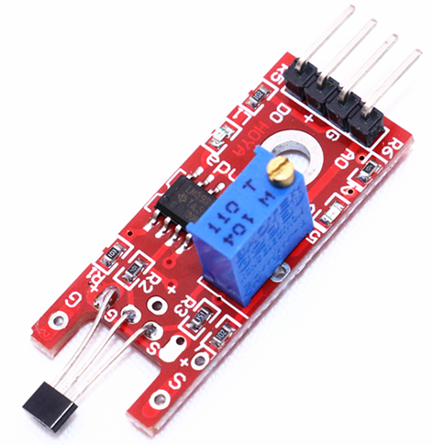 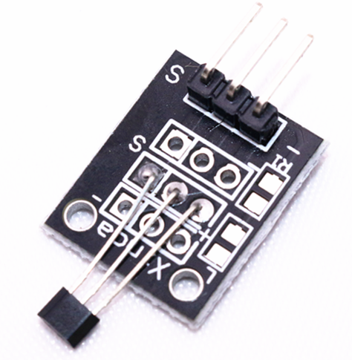

## Experimental Procedures

**Step 1:** Connect circuit as shown in the following photo:

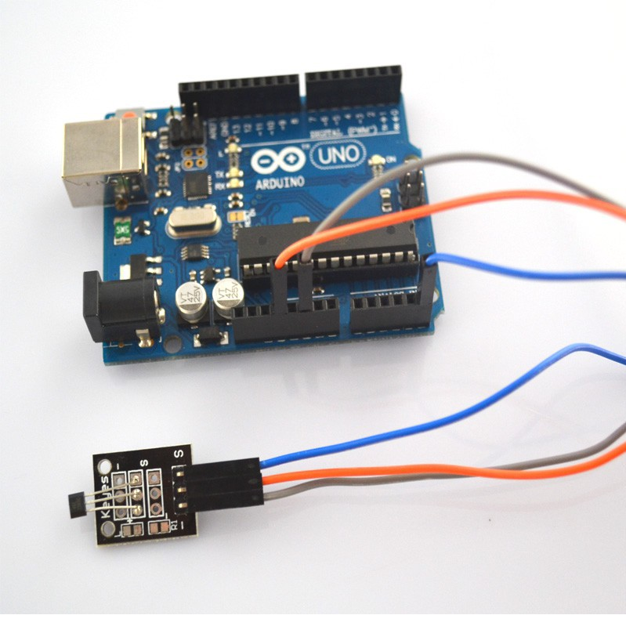

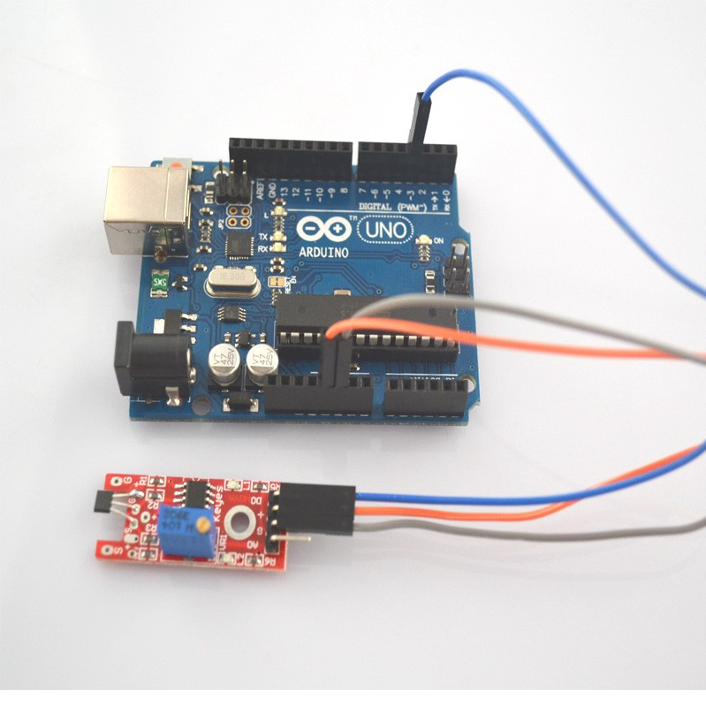

**Step 2:** Program (please refer to the example code on the CD or official website)

**Step 3:** Compile the program

**Step 4:** Burn the program into RobotLinking Uno board

## Experimental Summary

Linear hall and analog hall module are a very simple, very practical technology that is surprisingly easy to master. If you feel as though you're struggling, check out our video tutorials on [www.RobotLinking.com](http://www.sunfounder.com/) or ask us questions on our forum.

# Lesson 26 TRACKING MODULE AND AVOIDANCE MODULE

## Introduction

In this experiment, we will learn how to use the tracking module and avoidance module.

Infrared obstacle avoidance sensor is designed for the design of a wheeled robot obstacle avoidance sensor distance adjustable. This ambient light sensor Adaptable, high precision, having a pair of infrared transmitter and receiver, transmitter tubes emit a certain frequency of infrared, When detecting the direction of an obstacle (reflector), the infrared receiver tube receiver is reflected back, when the indicator is lit, Through the circuit, the signal output interface output digital signal that can be detected by means of potentiometer knob to adjust the distance, the effective distance From 2 ~ 40cm, working voltage of 3.3V-5V, operating oltage range as broad, relatively large fluctuations in the power supply voltage of the situation Stable condition and still work for a variety of microcontrollers, Arduino controller, BS2 controller, attached to the robot that can sense changes in their surroundings.

## Components

* 1 * RobotLinking Uno board
* 1 * USB cable
* 1 * tracking module
* 1 * avoidance module
* Dupont wires(Female to Male)

## Principle

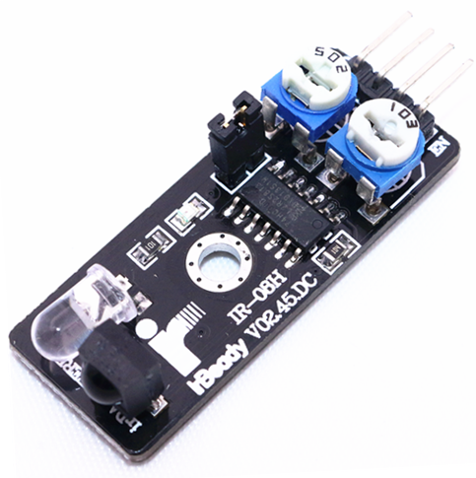 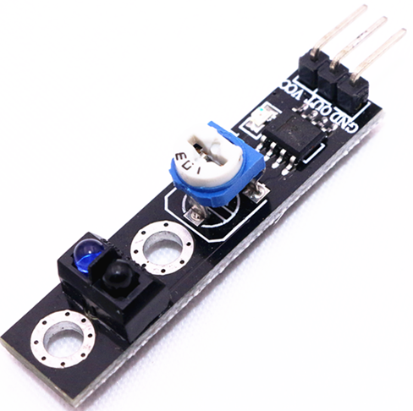

## Experimental Procedures

**Step 1:** Connect circuit as shown in the following photo:

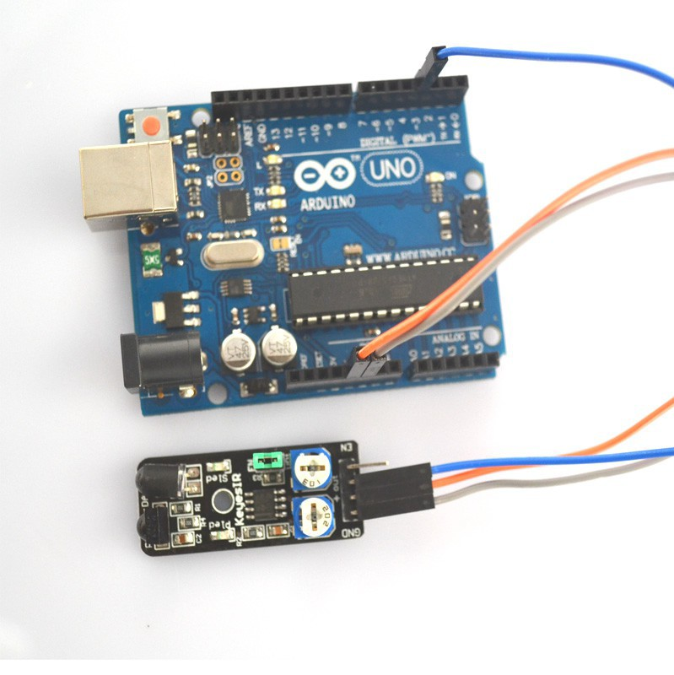

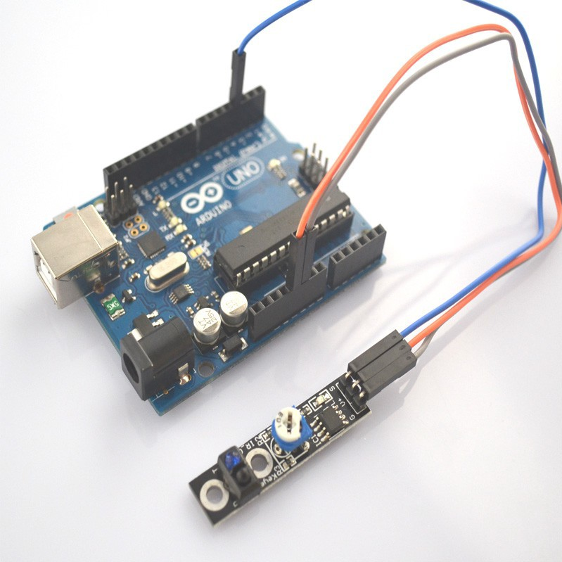

**Step 2:** Program (please refer to the example code on the CD or official website)

**Step 3:** Compile the program

**Step 4:** Burn the program into RobotLinking Uno board

## Experimental Summary

Tacking and avoidance module are a very simple, very practical technology that is surprisingly easy to master. If you feel as though you're struggling, check out our video tutorials on [www.RobotLinking.com](http://www.sunfounder.com/) or ask us questions on our forum.

# Lesson 27 ROTARY ENCODERS MODULE

## Introduction

In this experiment, we will learn how to use the rotary encoders module.

## Components

* 1 * RobotLinking Uno board
* 1 * USB cable
* 1 * Rotary encoders module
* Dupont wires(Female to Male)

## Principle

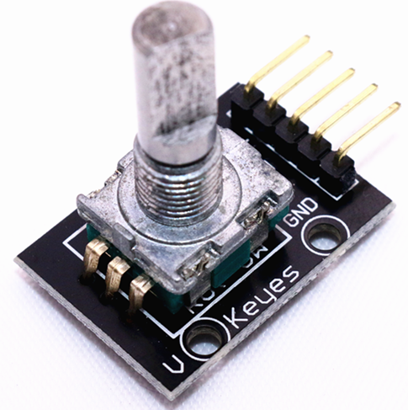

## Experimental Procedures

**Step 1:** Connect circuit as shown in the following photo:

GND-GND VCC-5V CLK-2 DT-3 SW-4

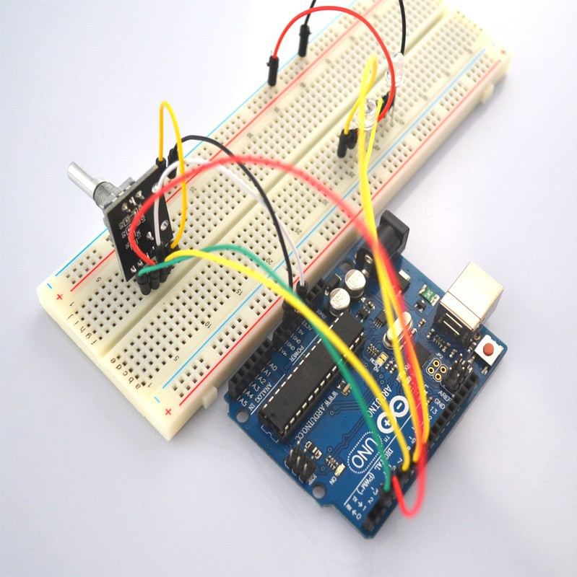

**Step 2:** Program (please refer to the example code on the CD or official website)

**Step 3:** Compile the program

**Step 4:** Burn the program into RobotLinking Uno board

**Step 5:** Open the TOOL→Serial Monitor, and we can turn the rotary so that the monitor will change the reading number.

## Experimental Summary

Rotary encoders module are a very simple, very practical technology that is surprisingly easy to master. If you feel as though you're struggling, check out our video tutorials on [www.RobotLinking.com](http://www.sunfounder.com/) or ask us questions on our forum.

# Lesson 28 1 CHANNEL RELAY MODULE

## Introduction

In this experiment, we will learn how to use the1 channel relay module.

Relay is a kind of component when the change of the input variables (incentive) to specified requirements, the output electric circuits of the charged amount occurs due to the step change of a kind of electrical appliances.This company produces the relay module can meet in 28 v to 240 v ac or dc power to control all kinds of other electric parts.MCU can be used to achieve the goal of timing control switch.Can be applied to guard against theft and alarm, toys, construction and other fields.Relay is an electrical control device.It has a control system (also called input circuit) and control system (also called the output circuit), the interaction between.Usually used in automatic control circuit, it is actually with a small current to control large current operation of a kind of "automatic s

## Components

* 1 * RobotLinking Uno board
* 1 * USB cable
* 1 * 1 channel relay module
* Dupont wires(Female to Male)

## Principle

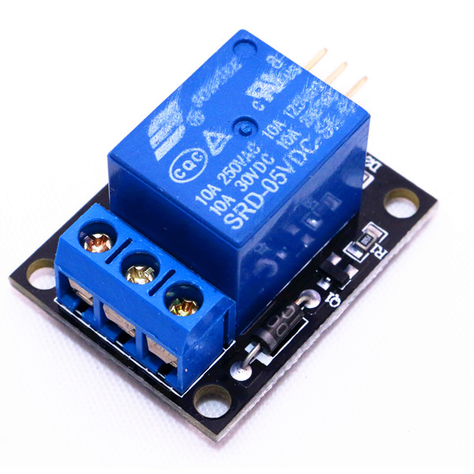

## Experimental Procedures

**Step 1:** Connect circuit as ：

Uno R3 GND --> Module pin -

Uno R3 +5V --> Module pin +5V

Uno R3 Digital 2 --> Resistor or Not-->Module SW

**Step 2:** Program (please refer to the example code on the CD or official website)

**Step 3:** Compile the program

**Step 4:** Burn the program into RobotLinking Uno board

## Experimental Summary

1 channel relay module are a very simple, very practical technology that is surprisingly easy to master. If you feel as though you're struggling, check out our video tutorials on [www.RobotLinking.com](http://www.sunfounder.com/) or ask us questions on our forum.

# Lesson 29 HEARTBEAT MODULE

## Introduction

This project uses bright infrared (IR) LED and a phototransistor to detect the pulse of the finger, a red LED flashes with each pulse. Pulse monitor works as follows: The LED is the light side of the finger, and phototransistor on the other side of the finger, phototransistor used to obtain the flux emitted, when the blood pressure pulse by the finger when the resistance of the photo transistor will be slightly changed. The project's schematic circuit as shown, We chose a very high resistance resistor R1, because most of the light through the finger is absorbed, it is desirable that the phototransistor is sensitive enough. Resistance can be selected by experiment to get the best results. The most important is to keep the shield stray light into the phototransistor. For home lighting that is particularly important because the lights at home mostly based 50HZ or 60HZ fluctuate, so faint heartbeat will add considerable noise.

When running the program the measured values are printed. To get a real heartbeat from this could be challenging.

## Components

* 1 * RobotLinking Uno board
* 1 * USB cable
* 1 * 1 heartbeat module
* Dupont wires(Female to Male)

## Principle

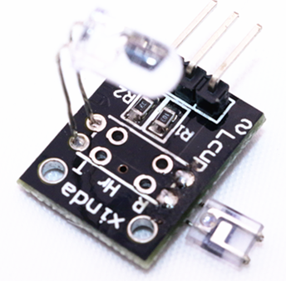

## Experimental Procedures

**Step 1:** Connect circuit as ：

Sensor pin S connect to Uno R3 pin Analoog 0 / A0

Sensor pin + (middle pin) connect to Uno R3 pin 5+

Sensor pin - connect to Uno R3 pin GND

**Step 2:** Program (please refer to the example code on the CD or official website)

**Step 3:** Compile the program

**Step 4:** Burn the program into RobotLinking Uno board

## Experimental Summary

Heartbeat module are a very simple, very practical technology that is surprisingly easy to master. If you feel as though you're struggling, check out our video tutorials on [www.RobotLinking.com](http://www.sunfounder.com/) or ask us questions on our forum.